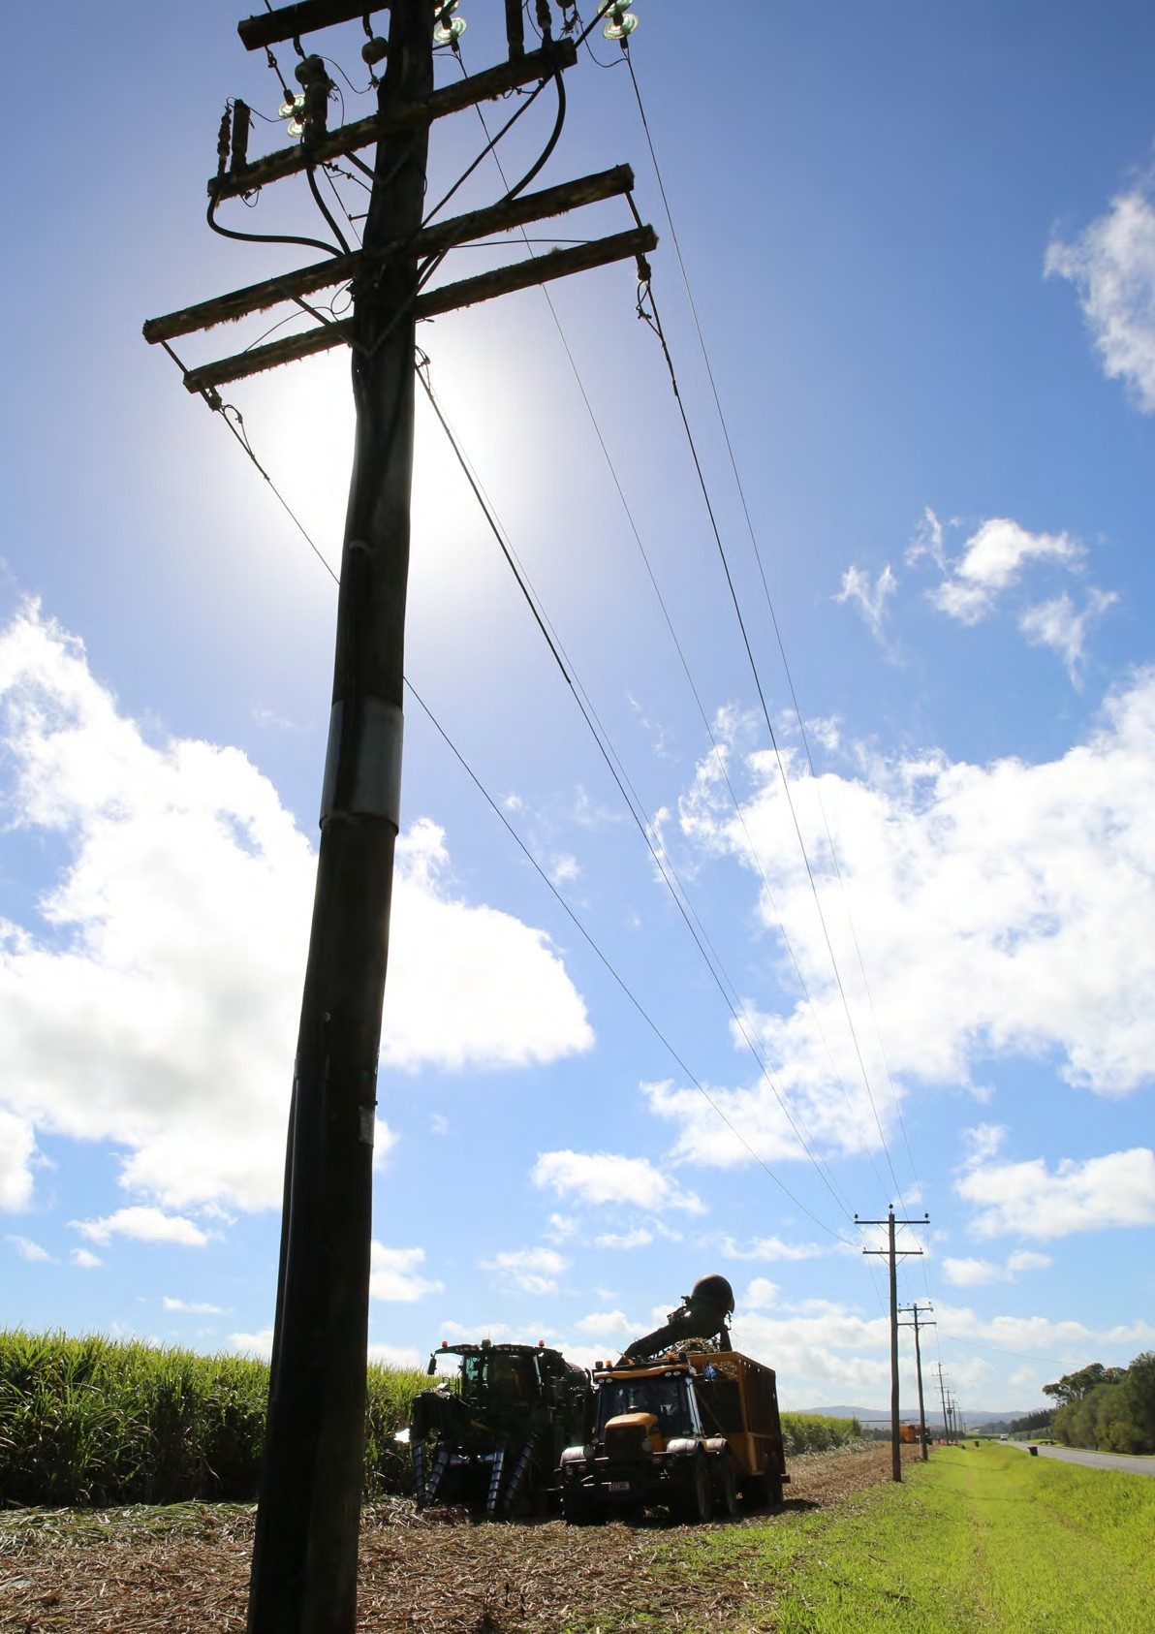

Version 2021.12.23

**CANEGROWERS Workplace Health and Safety Guide**

for sugarcane farms

#### **Acknowledgements**

This document was prepared by Professor Richard Franklin and Miss Hannah Mason from James Cook University on behalf of CANEGROWERS. This document is based on a range of resources including 10 Steps to Safety Management Handbook, and documents and webpages from the Department of Workplace Health and Safety Queensland, SafeWork Australia, Australian Centre for Agricultural Health and Safety, National Farmers’ Federation, WorkSafe New Zealand, SafeWork South Australia, WorkSafe Tasmania, and Dairy Australia.

We would like to thank and acknowledge the following: The 10 Steps to Safety Management Handbook which was compiled by Gary Halliday, CANEGROWERS Burdekin Limited with assistance from Matthew Leighton, Bundaberg CANEGROWERS Ltd, for use within the Sugar Industry. This was used as a guide for this Handbook. The 10 Steps to Safety Management Acknowledges the following: The Australian Centre for Agricultural Health and Safety for allowing use of their Practical Guide for Health and Safety in the Farm Workshop (2005), a product of the Farm Machinery Safety Project, a program of Farmsafe Australia with funding from the Commonwealth Department of Health and ageing.

Sources utilised in the development of this safety guide include:

* AgriFutures - [https://www.agrifutures.com.au/](https://www.agrifutures.com.au/%20%20)
* The Australian Centre for Agricultural Health and Safety - <https://aghealth.sydney.edu.au/>
* Dairy Australia - <https://www.dairy.com.au/>
* Farmsafe Australia - <https://farmsafe.org.au/>
* Fragar LJ, Franklin RC, Allen C, Harding W (2001) Occupational Health and Safety Risks Associated with sugarcane production.

<https://aghealth.sydney.edu.au/wp-content/uploads/2019/05/ohs_risk_sugarcane_production.pdf>

* National Farmers’ Federation - <https://nff.org.au/>
* Queensland Cane Growers Organisation Limited - <http://www.canegrowers.com.au/>
* WorkSafe New Zealand - <https://www.worksafe.govt.nz/>
* SafeWork South Australia - <https://www.safework.sa.gov.au/>
* We Are Union: OHS Reps - <https://www.ohsrep.org.au/>
* Workplace Health and Safety Queensland, [Serious About Farm Safety](https://www.worksafe.qld.gov.au/__data/assets/pdf_file/0019/20197/5564-serious-about-farm-safety.pdf) report
* WorkSafe Tasmania - <https://www.worksafe.tas.gov.au/>

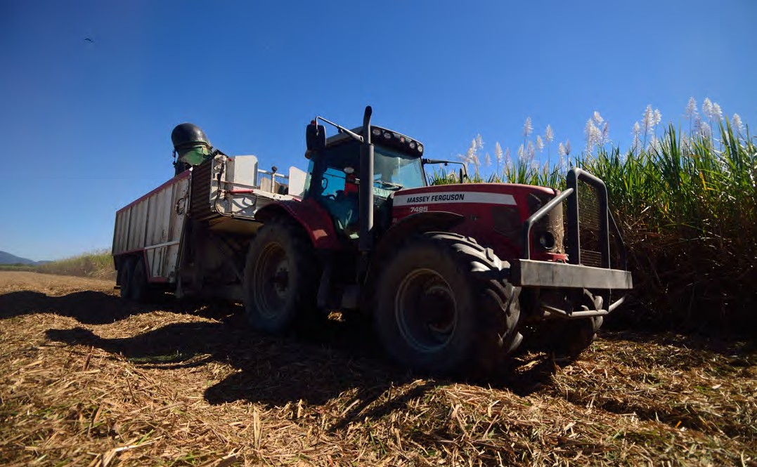

CANEGROWERS is committed to fostering effective management of workplace health and safety practices and to decrease work-related illness or injury.

Rural industry has the highest rate of workplace accidents in Australia, therefore it is essential to reduce human suffering and financial costs sustained by the Queensland rural community, particularly the sugar cane industry, as a result of workplace related illness or injury.

This booklet has been compiled to provide a guide to risk management of sugarcane growing processes. It is intended as a starting point for growers to become aware of, and compliant with, legislative requirements.

**Safety is an integral part of farming operations and must be given due consideration in rural communities.**

Local safety issues and other work procedures and instructions may be added to the appropriate sections of this publication. It is important that each member of a workplace clearly understands the action of the other to ensure safe working procedures. The actions of any member of the workplace must not cause or create a risk of injury to any person on or near the farming workplace.

**Table of Contents**

Acknowledgements 2

Message 3

Disclaimer 6

How to use this guide 7

Key things you need to know about Workplace Health and Safety (WHS) 9

Who is responsible for managing WHS risks? 9

What are the steps to managing WHS risks? 11

Induction and Training 14

Record Keeping 17

What do you need to keep? 17

Farm mapping 18

Chemical Safety 19

Electricity Safety 20

Machine Safety 21

Quad Bike Safety 22

Workshop Safety 23

Cane Firing 24

Confined Spaces 25

Working Alone 25

Contractors 26

Sexual Harassment 27

Mental health 27

Emergencies 28

Emergency Procedures 28

First Aid 28

Investigating and Reporting 28

COVID-19 and the Workplace 30

COVID-19 Risk Management 30

Seasonal Workers 31

Vaccinations 31

Workers Compensation 32

Appendix 1: Example Policies 33

Example Policy: Responsibilities for Workplace Health and Safety 34

Example Policy: Workplace Hazard Identification and Audit 36

Example Policy: Incident and Injury Reporting 37

Example Policy: WorkCover Claims Administration 39

Example Policy: Contractors - Occupational Health and Safety Provisions 41

Example Policy: Drugs, Alcohol and Fitness for Work 44

Example Policy: Bullying and Aggression at Work 45

Example Policy: Sexual Harassment 46

Example Policy: Working Alone 50

Example Policy: Visitors on Farm 51

Example Policy: Induction 52

Example Policy: Quad bike safety 53

Appendix 2: Exemplars of Management Forms and Audit Checklists 54

Exemplar Management Form: Workplace Induction 55

Exemplar Management Form: Formal Record of Safety Discussions 56

Exemplar Management Form: Safe Purchasing 57

Exemplar Management Form: Safe Work Procedures 58

Exemplar Management Form: Safe Work Method Statement 59

Exemplar Audit Checklist: Training and Competencies 61

Exemplar Audit Checklist: Working in Proximity to Overhead Electrical Lines 62

Exemplar Audit Checklist: Cane Railway System 64

Exemplar Audit Checklist: Crossings 65

Exemplar Audit Checklist: Crop Clearances 66

Exemplar Audit Checklist: Internal Roadways and Access to Crop 67

Exemplar Audit Checklist: Harvesters/Hay Balers 68

Exemplar Audit Checklist: Emergency Response and Incident Management 69

Exemplar Audit Checklist: Incident Reporting and Investigation 70

Exemplar Audit Checklist: Irrigation Pumps, PTO Pumps, Hammer Mills,

or Other High-Risk Plant 71

Exemplar Audit Checklist: Workshop 72

Exemplar Audit Checklist: Hazardous Substances (Management Systems) 75

Exemplar Audit Checklist: Hazardous Substances (Regulation and Risk Assessment) 76

Exemplar Audit Checklist: Hazardous Substances (Provision of Information) 77

Exemplar Audit Checklist: Hazardous Substances (Storage and Handling) 78

Exemplar Audit Checklist: Hazardous Substances (Mixing and Use) 80

Exemplar Audit Checklist: Hazardous Substances (Disposal) 81

Exemplar Audit Checklist: Hazardous Substances (Records and Health Surveillance) 82

Exemplar Audit Checklist: Managing Safety 83

Exemplar Audit Checklist: Shared Workplace - Delivery Points 84

Appendix 3: Example Reports and Registers 85

Example Reports and Registers: Training 86

Example Reports and Registers: Contractor Visitation 87

Example Reports and Registers: Job Safety Analysis 88

Example Reports and Registers: Hazard Register 90

Example Reports and Registers: Registrable Plant Record 91

Example Reports and Registers: Hazardous Substance List 92

Example Reports and Registers: Hazardous Substance Exposure 93

Example Reports and Registers: Chemical Use 94

Example Reports and Registers: Risk Assessment – Delivery Points 95

Example Reports and Registers: Emergency Management 97

# Disclaimer

This publication is distributed on the terms and understanding that:

1. CANEGROWERS are not responsible for the results of any action taken on the basis of information in this publication, nor for any error in, or transmission from, this publication; and
2. CANEGROWERS is not engaged in rendering legal, professional or other advice or services.

CANEGROWERS expressly disclaim all or any liability or responsibility to any person, whether or not a purchaser or reader of this publication, in respect of anything, and of the consequences of anything, done or omitted to be done, by any such person in reliance, whether wholly or partially, upon the whole or any part of the contents of this publication.

By using this guide, you hereby signify that you have read and understood this disclaimer and agree to abide by the terms and conditions herein. You agree that you are responsible for your own conduct and respective consequences.

The information provided in this guide is general advice only. It has been prepared without taking into account your personal objectives, situation or needs. This publication should be used as a guide to help improve safety in your business, we recommend seeking professional advice for more detailed and specific information about your needs. Legislative requirements vary between states and territories. This document has a focus on Queensland legislation. Therefore, it is necessary to check with the relevant state or territory occupational health and safety authority for appropriate information.

This guide includes links to external websites. Information provided in these hyperlinks was correct as of July 2021. CANEGROWERS is Queensland Cane Growers Organisation Ltd - ABN 94 089 992 969.

# How to use this guide

The purpose of this guide is to outline the process and responsibilities to ensure that your farm is adhering to best practice approaches to sugarcane farm workplace health and safety. This document is a guide and provides general advice, it does not take into account your personal objectives, situation, circumstances or needs. As such the policies, forms, checklists, etc are exemplars and should be tailored to meet your needs.

You can start at the beginning of this guide and read through to the end or jump to particular sections. However, we do suggest that you review *Key things you need to know about Workplace Health and Safety* through to *record keeping* to gain an understanding of the importance of WHS issues and how to address these.

Hyperlinks have been used throughout this document which link to Queensland and Australia-specific safety guidance and policy. To access these links, you will need to have internet connection and access to an internet browser.

Managing health and safety is an ongoing process that should form part of the way you do business. After you have established your Workplace Health and Safety Management System you need to find out how well it is working by regularly checking and evaluating each step.

Your processes, operations and staff may change over time and so may the risks. Make sure you continually review your WHS Management System to ensure it still addresses any workplace or legislative changes.

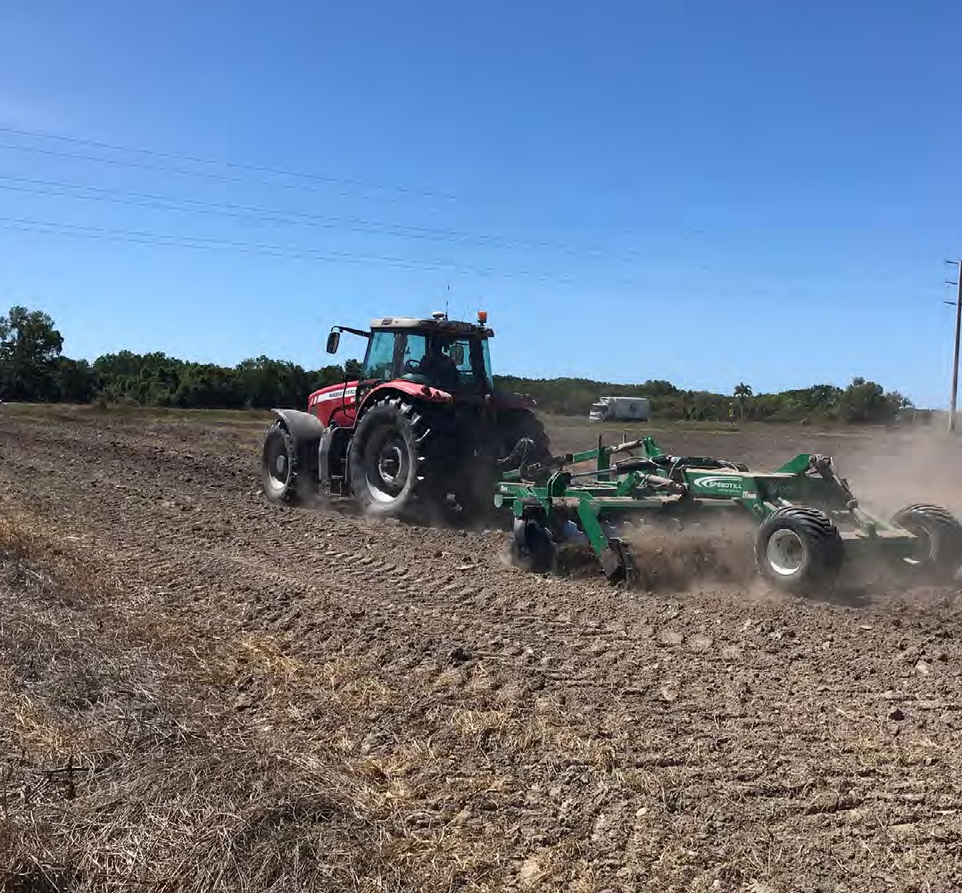

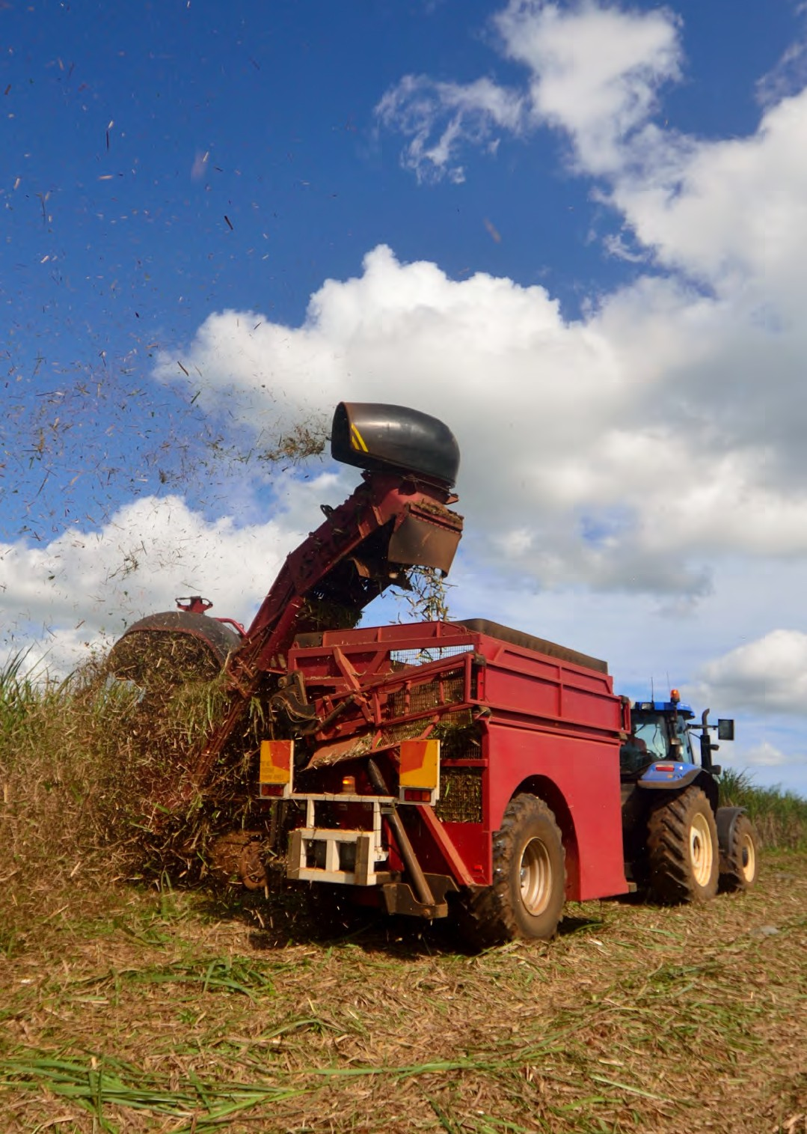

# Key things you need to know about Workplace Health and Safety (WHS)

In Queensland, workplace health and safety (WHS) is managed via the [Act and Regulation](https://www.legislation.gov.au/Details/C2018C00293). The following are points for you to consider for enhancing WHS in your business.

## Who is responsible for managing WHS risks?

The ‘person conducting a business or undertaking’ ([PCBU](https://www.safeworkaustralia.gov.au/law-and-regulation/duties-under-whs-laws/duties-pcbu)) who is usually the employer, must manage risks to health and safety by eliminating risks as much as is reasonably practicable.

Those responsible for preventing and managing risks include:

* Employers
* The self-employed
* Principal contractors
* Anyone who manages or controls a workplace
* Designers
* Manufacturers
* Importers and suppliers of plant, substances or structures that are used at work.

***Employers and self-employed persons*** must ensure the health and safety of people visiting or working at their places of work, who are not their employees, by not exposing them to risk - includes contractors.

***Manufacturers, designers and suppliers*** of plant and substances for use by people at work must make sure that they are safe and without risks to health when properly used. They must also supply adequate information to ensure safe use.

***Employees*** also have responsibilities. Workers must take reasonable care of the health and safety of themselves and others and co-operate with management in its efforts to comply with work health and safety requirements.

* Each of these WHS obligations must be met in all agricultural industries and on each individual enterprise. This applies to all types of work and all workplaces that are covered by the *Work Health and Safety Act 2011* (WHS Act). Managing work health and safety risks within a workplace involves the elements of governance, prevention, response, and recovery.

#### **Safety Commitment**

To be effective, a safety management system requires the commitment and participation of all levels within an organisation. Gaining a commitment from workers requires an employer to demonstrate a corporate commitment. Such a commitment can include:

* The employer’s commitment through leadership and example, financial support and business priority
* Safety accountability as defined in the job description
* Establishing an ongoing safety program and the marketing and monitoring of all aspects of that program
* Setting of personal examples at all levels
* Compliance with safe work practices and procedures.

Ensure you have access to the relevant guidance material for your industry. The [Serious About Farm Safety](https://www.worksafe.qld.gov.au/__data/assets/pdf_file/0019/20197/5564-serious-about-farm-safety.pdf) report is a guide that can help you to develop health and safety management systems for small to medium sized agricultural businesses.

The [Sugar Industry Code of Practice 2005](https://ablis.business.gov.au/service/qld/sugar-industry-code-of-practice-2005/42274) provides practical guidance on how to comply with your WHS duties.

#### **Worker Consultation**

This important step involves communicating and consulting with your workers. When considering all the tasks that are undertaken in your business, it is important to involve workers in any decisions that may affect their health and safety. Often the people doing the job are best placed to offer advice on the hazards they face and ways to work safely.

Clear and open communication channels at all levels in the workplace will encourage everyone’s support for and participation in health and safety activities. Workers will more likely follow safety procedures if they have been involved in developing them. Whatever system is in use, it is essential that there is a clear commitment to safety of the owner and manager, and that this is obvious by the safety behaviour and activity taken on a day-to-day basis.

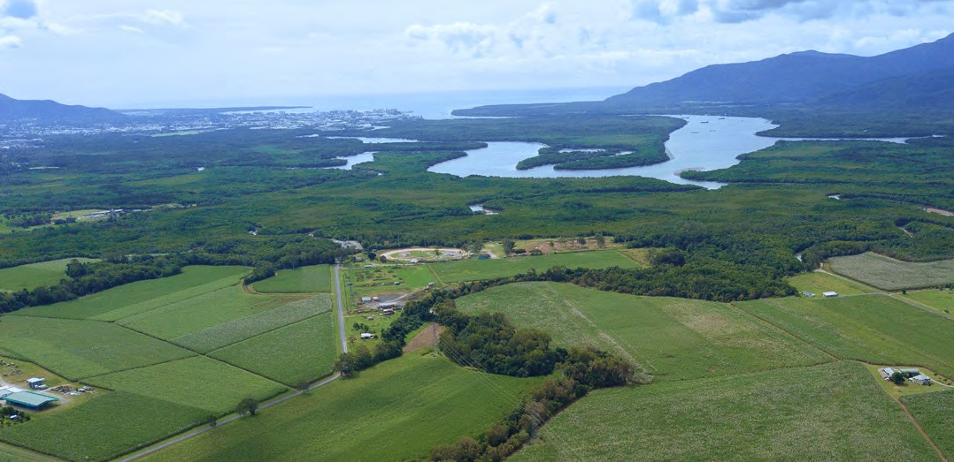

To communicate effectively with our workforce, we need to be aware of differing skills in language, literacy, and culture. We should adapt our communication style where necessary.

To find out more regarding consultation with workers, please see Part 5 of the [*Work Health and Safety Act 2011*](https://www.legislation.gov.au/Details/C2018C00293).

#### **Keep Communication Simple**

Consultation between employers and workers can be achieved in many ways and you should choose a style that best suits the situation. For your farming operations this may simply mean having regular direct discussions, which could involve:

* Gathering workers at the start of work
* Encouraging workers to raise any safety concerns they may have
* Reporting on action taken
* To address any identified hazards
* Informing workers about any planned changes that may have implications for their health and safety
* Discussing any new hazards and possible safety measures
* Conducting a ’walk around’ safety inspection.

#### **Workplace Health and Safety Representatives (WHSR)**

The *Workplace Health and Safety Act 2011* promotes the involvement of workers in the decision-making processes associated with health and safety risk management in the workplace. Under the *Act* workers may elect a Workplace Health and Safety Representative on their own initiative or at their employer’s suggestion. A WHSR cannot be chosen by the employer.

An employer must tell the relevant WHSR about any workplace incident or any proposed changes that may affect health and safety in the workplace and if a workplace health and safety inspector is expected to visit the workplace.

WHSR’s are entitled to conduct inspections of a workplace to help resolve workplace health and safety issues.

For more information regarding Workplace Health and Safety Representatives, please see Part 5, Division 3 of the *Act*: <https://www.legislation.gov.au/Details/C2018C00293>

#### **Workplace Health and Safety Officer (WHSO)**

Workplace Health and Safety Officers provide expert advice to employers to help them meet their obligations under the *Workplace Health and Safety Act 2011*. WHSO’s are trained to identify health and safety hazards and help implement risk assessments in the workplace and are chosen by the employer.

All employers with 30 or more workers are required by law to appoint a WHSO to help eliminate health and safety risks. An approved work health and safety officer course is Certificate IV in Work Health and Safety (BSB41419), which must be conducted by an approved registered training organisation (RTO).

To see a list of RTOs who deliver WHSO training, and other information related to WHSOs, please see the following: [https://www.worksafe.qld.gov.au/licensing-and-registrations/work-health-and-safety-training](https://www.worksafe.qld.gov.au/licensing-and-registrations/work-health-and-safety-training/registered-training-organisations)

## What are the steps to managing WHS risks?

Risk management is a proactive process that systemically covers all reasonably foreseeable hazards and risks.

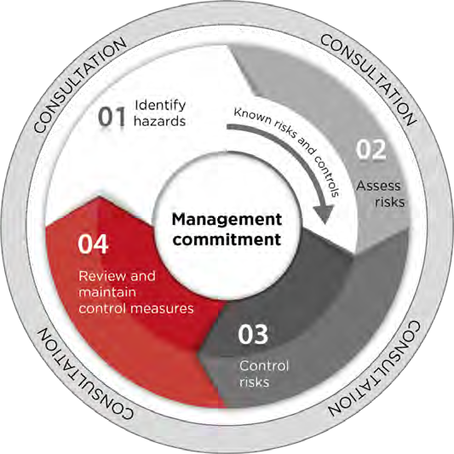

*Source:* [*Safe Work Australia*](https://www.safeworkaustralia.gov.au/)

**Step 1 - Identify hazards** (find out what could cause harm)

Safety hazards must be identified in a systematic way. This means that property owners, managers and workers must identify those jobs and situations that may cause injury or illness, not only to people doing the work, but also to bystanders and visitors.

Hazard identification should be an ongoing and be carried out:

* At least annually
* When systems are changed
* New equipment
* Changed facilities
* Changed practice.

All workers should be actively encouraged to report anything that could be considered hazardous to health and safety – any unsafe condition, or unsafe action needs to be identified and action taken to make the system safe.

**Step 2 - Assess risks** (understand the nature of the harm that could be caused by the hazard, how serious the harm could be, and the likelihood of it happening)

Risk associated with each hazard must be assessed in terms of the severity of the potential harm that could occur, and the likelihood that such an outcome could occur – generally greater if workers are frequently exposed to the hazard. The risk matrix may help with assessing the risk:

|  |  |  |  |  |
| --- | --- | --- | --- | --- |
| LIKELYHOOD:  How likely could it happen? | CONSEQUENCES: How severely could it hurt someone? | | | |
| EXTREME  Death, permanent disablement | MAJOR  Serious bodily injury | MODERATE  Medical / casualty treatment | MINOR  First Aid only, no lost time |
| VERY LIKELY- could happen frequently | 1 HIGH  Act Now | 2 HIGH  Act Now | 3 HIGH  Act Now | 4 HIGH  Act Now |
| LIKELY- could happen occasionally | 2 HIGH  Act Now | 3 HIGH  Act Now | 4 MEDIUM  Act ASAP | 5 MEDIUM  Act ASAP |
| UNLIKELY- could happen but rare | 3 HIGH  Act Now | 4 MEDIUM  Act ASAP | 5 MEDIUM  Act ASAP | 6 LOW  Plan/Review |
| VERY UNLIKELY-  could happen probably never will | 4 MEDIUM Act ASAP | 5 MEDIUM Act ASAP | 6 LOW  Plan/Review | 7 LOW  Plan/Review |

*Source:* [*Safe Work Australia*](https://www.safeworkaustralia.gov.au/)

**Step 3 - Control risks** (implement the most effective control measure that is reasonably practicable in the circumstances and ensure that it remains effective over time)

Risks must be controlled to prevent injury. The hierarchy, or order of effectiveness, is as follows:

1. ***Elimination of the hazard:*** Where possible, the hazard must be eliminated, or removed from the workplace. This is obviously the most effective way to reduce risk. While it is often not possible to eliminate a hazard, WHS regulations require employers to consider this option. If it is not possible, then the next most effective solution should be sought and put in place.
2. ***Substitution for a hazard of lesser risk:*** Where it is not possible to eliminate a hazard altogether, consider whether the hazard can be substituted for something that will do the same job, but is less risky.
3. ***Isolation of hazard from worker and other engineering controls:*** In most hazardous situations it is possible and practicable to improve the design of work and/or isolate the worker from the hazard. This is the basis of most of the safety improvements that should be put in place by horticultural enterprises to reduce risk of injury as well as to be compliant with WHS regulations.
4. ***Administrative controls:*** Administrative controls include safe operating procedures or rules, organising work in such a way that reduces risk, giving safety induction and training to workers, supervising unskilled workers and providing safety information to workers about the safety risk associated with the work to be done and how these risks can be minimised.
5. ***Personal protective equipment:*** Personal protective equipment must be provided and used where workers cannot be protected from a hazard by a control measure higher up the order (1-4 above). This includes providing helmets to protect from head injury for riders of motorcycles and ATVs. These guidelines suggest the higher order controls in the first instance, with the lower order, less effective controls that depend on individual behaviour lower in the list. In practice, best practice in WHS risk management will require a mix of controls for the high-risk hazards.

**Step 4 - Review control measures** (review the control measures to ensure they are working as planned)

These steps are not to be taken on a once-off basis. These processes should become a key part of the management of the whole business. Successful businesses invest significantly in WHS in terms of time, money and commitment at all levels. These businesses understand that overall performance of the business benefits from good WHS practice. Such businesses do not accept that the major responsibility for workplace health and safety rests in the workers themselves, rather the opposite – that safety is a key management responsibility, and involving workers is a critical management skill. Records of all activity in your WHS program must be kept.

Consider the following questions:

* + How effective are the control measures? Are they working as intended? Ensure that the control measures have not created new hazards.
  + How accurate is the risk assessment process?
  + Are workers actively involved in your health and safety program? Are they openly raising health and safety concerns and reporting problems promptly?
  + Have new work methods, new equipment or chemicals made the job safer?
  + Are safety procedures being followed? Is personal protective equipment being worn as instructed?
  + Has instruction and training provided to workers about how to work safely, been successful?
  + Are the frequency and severity of incidents causing injury reducing over time?
  + Are safety records accurate and up to date?

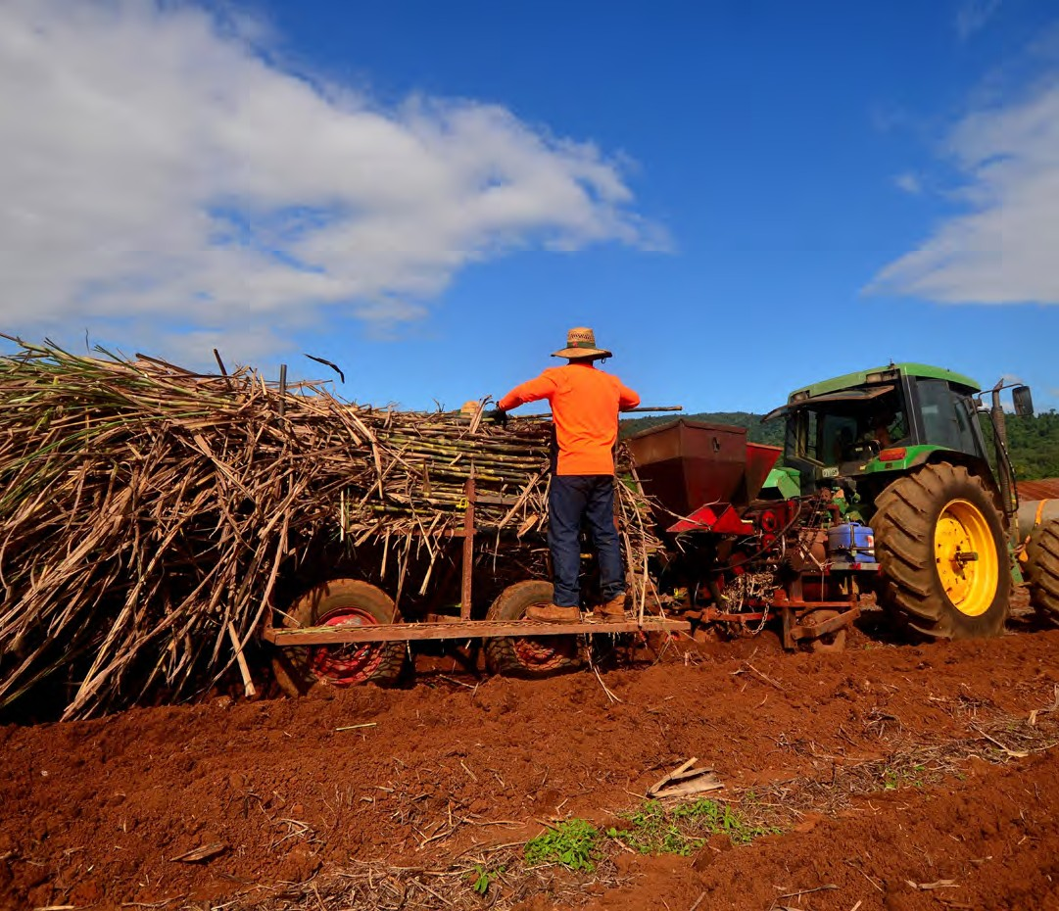

# Induction and Training

The [induction process](https://www.business.qld.gov.au/running-business/employing/taking-on-staff/inductions/whs) is intended to provide initial instruction and training on safety and environmental issues associated with the relevant range of activities undertaken by people in the workplace. Induction is an ongoing process, and your plan should cover the first few months a staff member is in a new role, experiences role change, or acquires new duties (new procedures, new equipment etc). It is intended as a compulsory and systematic process resulting

in developing basic competency for a person to perform a task safely and without environmental harm. It is the responsibility of the employer to give workers the information, training, and supervision they need.

Inductions involve visitors and contractors undertaking a task in a specific or general area and to full or part time workers into the business generally and whenever they enter a specific area or undertake a new task.

***Process:***

Types of induction include:

* + Workplace general induction
  + Workplace specific task induction
  + Industry delivery point induction
  + Delivery point site specific induction
  + Industry electrical induction
  + Electrical work activity induction
  + Job specific induction.

***Visitors and Contractors*** should be given instruction and training on ***site and activity specific*** aspects relevant to their proposed activities on site.

***Workers*** should be given a general induction on ***commencement*** of employment including instruction and training on safety and environmental awareness.

***Workers*** should also be given instruction and training relating to safety and environmental issues associated with the

***specific site or area*** they are required to work.

***Workers*** should also be given instruction and training on safety and environmental issues associated with the ***specific tasks*** they are required to work in. This may involve periodic inductions or revisiting induction materials throughout the workers employment.

#### **Accountabilities:**

The farm owner/manager will be responsible the maintenance of the Induction Register. The farm owner/manager will be responsible to ensure persons only perform work that is inducted and recorded in the Induction Register.

The outcomes of the previous three steps will establish what information needs to be communicated to workers so that they can do their jobs safely.

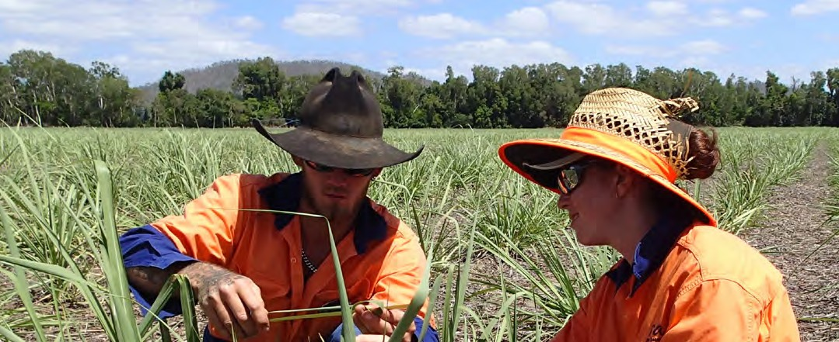

#### **Information and training can be provided using:**

* + Procedure manuals
  + Equipment operating/maintenance manuals
  + Material safety data sheets for chemicals
  + Written work instructions
  + Safety notice board
  + Training videos
  + Site maps.

#### **Managers or supervisors can provide on the job training in such things as:**

* + Induction of new employees
  + Specific hazards and risks associated with the job
  + Safe work procedures
  + Emergency procedures
  + Use and maintenance of personal protective clothing and equipment.

#### **Organise an expert to provide on-site training in such things as:**

* + Safe use of new or specialized equipment
  + Manual handling

#### **Workers may be sent on external training courses for things such as:**

* + First aid
  + Health and safety representative training
  + Certification for plant users and operators.

N.B. Persons using or operating certain types of plant and equipment require certificates of competency under the *Workplace Health and Safety Act* and *Regulations*. Training is obtained from a training provider or on the job under the direct supervision of an already certified operator.

#### **Supervision**

Adequate supervision is an integral part of ensuring that workers have understood instructions and have the necessary skills to do their job safely. Supervisors and managers therefore need to know their responsibilities and be properly trained to supervise staff.

The degree of supervision required will depend on each individual’s knowledge and experience - new and less skilled workers will need closer supervision.

Evaluate the competency of your workers on a regular basis and if you notice any deterioration in their performance, provide refresher training to ensure they continue to operate in a safe manner.

#### **New worker induction**

Introducing new staff into a workplace by providing the essential initial training is commonly called induction. Inducting your staff will help to make your workplace safer and more productive. The following suggestions are an aid to deciding what format these inductions would best suit your workplace.

* Involve key people in the induction, for example the new worker’s supervisor, health and safety representatives and co-workers
* Pace the induction so you don’t overwhelm the new worker with too much information
* Provide clear instructions and ensure they are understood
* Show (don’t just tell) the new worker how to perform the tasks. Emphasise main points
* Encourage the new worker to ask questions
* Don’t assume any prior knowledge, training or experience. Your workplace, equipment, tools and work practices may be different. Go over things that may seem ‘common sense’ despite the new employee’s background
* Consider the language, cultural and literacy needs of the new worker
* Ensure that they are supervised while they perform the tasks until they demonstrate they are competent. Correct any mistakes immediately.

Check that the new worker has understood what they have been told or shown. The [WorkSafe Queensland Induction](https://wcq-search.squiz.cloud/s/redirect?collection=wcq-meta&url=https%3A%2F%2Fwww.worksafe.qld.gov.au%2F__data%2Fassets%2Fword_doc%2F0024%2F16539%2Finduction-checklist.docx&auth=Z4Xxe0VmJIAmNjR50uwWFA&profile=_default&rank=2&query=induction)  [checklist](https://wcq-search.squiz.cloud/s/redirect?collection=wcq-meta&url=https%3A%2F%2Fwww.worksafe.qld.gov.au%2F__data%2Fassets%2Fword_doc%2F0024%2F16539%2Finduction-checklist.docx&auth=Z4Xxe0VmJIAmNjR50uwWFA&profile=_default&rank=2&query=induction) may be used to support your new workers.

#### **Training**

[Training](https://www.worksafe.qld.gov.au/safety-and-prevention/creating-safe-work/training-and-supervision) can be conducted using a mix of formal and informal methods, and some workers will need training to carry out their work safely. Some workers may need information on-the-job training such as working alongside a training buddy. Workers should be trained for specific tasks they will perform, and training and supervision should be ongoing.

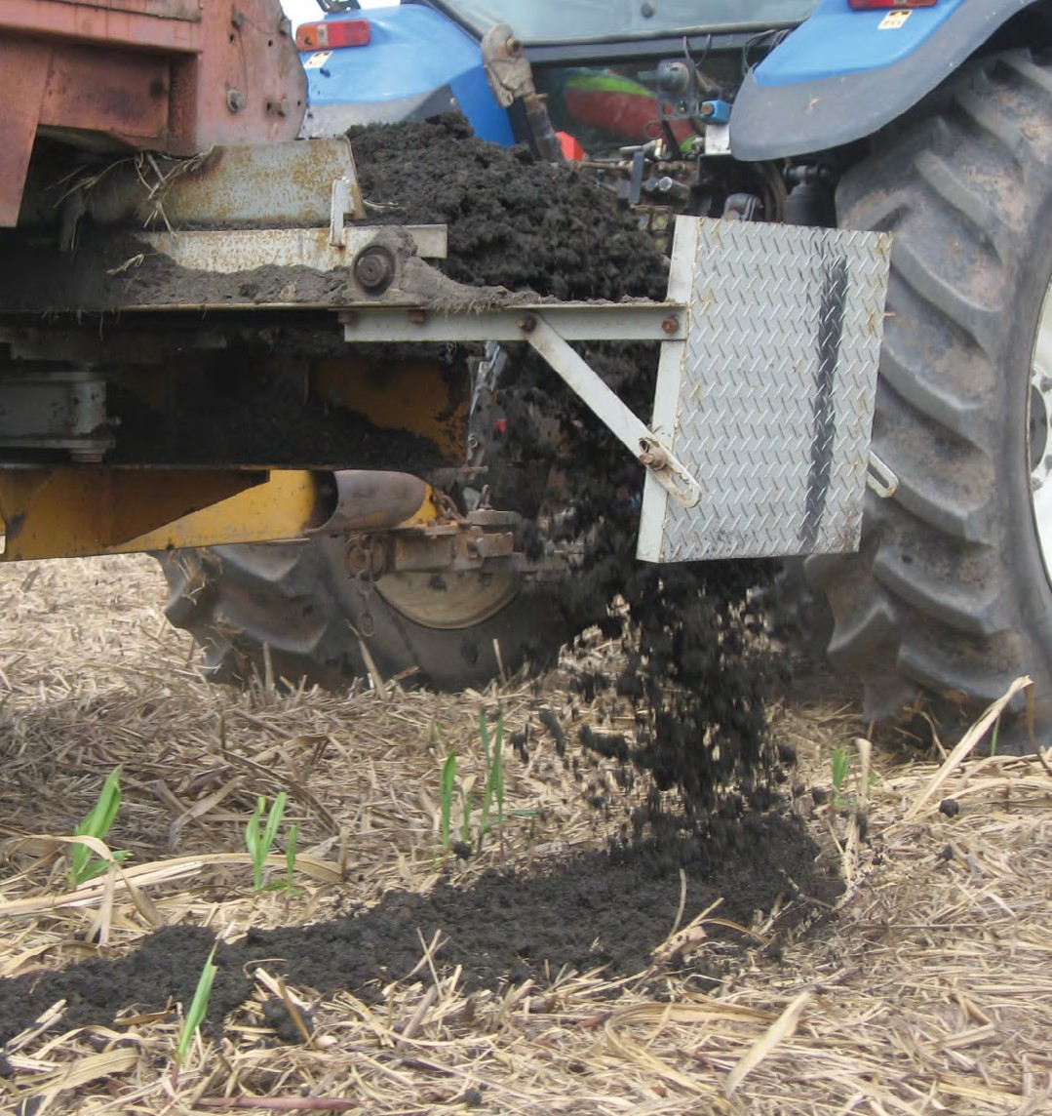

# Record Keeping

#### **Record Your Information**

It is important to document your health and safety activities and keep these records for the sake of:

* Meeting legal requirements
* Providing information to workers, and
* Monitoring the health and safety performance of your business.

Keeping records of the activities in your workplace makes managing health and safety easier.

## What do you need to keep?

#### **Hazard identification, risk assessment and control process**

These records include checklists, risk assessment information and risk control plans. They provide evidence of your health and safety activities and help you review and improve the health and safety performance of your business.

#### **Maintenance of plant and equipment**

These records enable you to schedule regular inspections and provide evidence of maintenance carried out. Keep these records with manufacturers specifications and operator’s manuals. Maintenance records also improve the resale value of equipment by providing a complete history.

#### **Accidents and incidents**

These records enable you to identify hazards, monitor trends and take the appropriate action to prevent recurrence. Near misses or dangerous occurrences should also be recorded, since these are often a warning signal of a future, preventable accident. The *Workplace Health and Safety Act* and *Workers Compensation Act* requires employers to maintain records of accidents and injuries. All factors that caused the incident must be properly addressed.

#### **Hazardous Substances Register**

This is a list of all chemicals used at the workplace including a collection Material Safety Data Sheets MSDS, which can be obtained free from the chemical supplier/manufacturer. Record this information on the supplied *Hazardous Substances Register*. The register should be kept as an assessable source of information for workers using chemicals. If you store or handle dangerous goods you may also need to keep records relating to these activities.

#### **Training Records**

It is essential that you have a record of the training that has been provided to every employee, these include a worker’s relevant experience, qualifications, personal details, and emergency contacts, which should include details of the training content, who conducted it and when it was provided.

**ALL RECORDS NEED TO BE KEPT UP TO DATE TO BE OF THE GREATEST BENEFIT**

# Farm mapping

An accurate farm map should be provided to staff and contractors, or anyone who operates machinery. To simplify identification try to use different bright colours to identify different hazards. Include photos to clarify the details of your site map.

The farm map should identify hazards such as:

* Rail lines (State rail or local sugar mill) and crossings
* Delivery Points
* Roadways (sealed and unsealed)
* Water ways and drainage channels
* Power lines, poles and stay wires and underground cabling
* Boundary fences or markers
* Irrigation pumps, pipelines, outlets.

Maps and mapping tools for agricultural projects are available on the [Business Queensland](https://www.business.qld.gov.au/industries/farms-fishing-forestry/agriculture/agribusiness/one-stop-service/support/mapping) website.

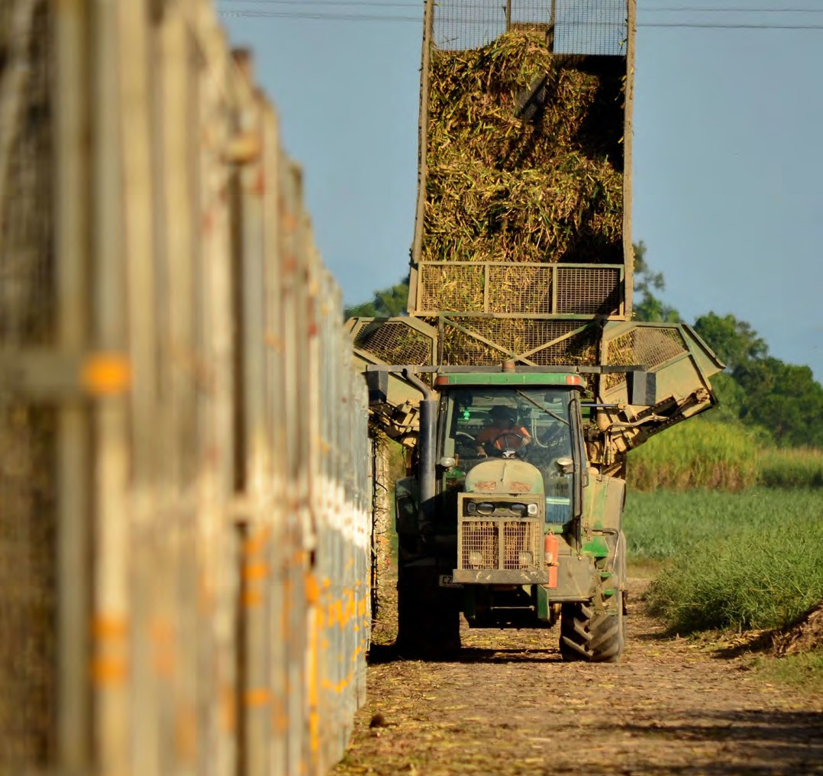

# Chemical Safety

[Hazardous chemicals](https://www.safeworkaustralia.gov.au/safety-topic/hazards/chemicals/classifying-chemicals) can pose a significant risk to health and safety if they are not properly managed and may be toxic or poisonous to humans if exposure occurs. Examples of chemicals that cause adverse health effects include [carcinogens](https://www.safeworkaustralia.gov.au/safety-topic/hazards/carcinogens), chemicals that cause damage to the skin, and toxic chemicals. More specifically, [pesticides](https://www.worksafe.qld.gov.au/safety-and-prevention/hazards/hazardous-exposures/pesticides) (including

herbicides, insecticides, and fungicides) are chemicals commonly used in agricultural environments, and individuals may be exposed via contamination of the air, water, or food. The carrier or solvent component of the pesticide may also have health effects. Absorption can occur through inhalation, skin absorption, ingestion, or eye contact. Contamination from residue accumulation occurs when pesticide residues remain active or break down into substances which are toxic.

The effects of pesticide poisoning may occur quickly or develop gradually over a long period of time. Sometimes, long term poisoning, which builds up after repeated exposure is more dangerous because permanent damage has been done by the time the poisoning is treated. Toxic effects of pesticides can be acute (symptoms occur very quickly after exposure) or chronic (symptoms are delayed or ongoing).

Some pesticides are flammable which affects the safe storage of pesticides.

When assessing the degree of risk associated with a particular pesticide hazard, the following questions should be considered:

* How commonly are people affected by pesticides?
* How severe is the likely resulting illness?
* How often and for how long are people exposed to hazards associated with pesticides?

It is strongly recommended that all farm workers who use or are responsible for pesticides use on farms undertake a chemical safety accreditation course, such as the [AgVet Chemical Users Course from AusChem](https://www.auschemtraining.com.au/), available in each Australian state.

WorkSafe Queensland must be [notified](https://www.worksafe.qld.gov.au/safety-and-prevention/incidents-and-notifications/hazardous-chemical-notifications) immediately if hazardous chemicals are used, handled or stored under certain circumstances at your farm.

For hazard identification, risk, and risk control of chemicals please see:

* <https://www.worksafe.qld.gov.au/safety-and-prevention/hazards/hazardous-chemicals>
* [https://www.safeworkaustralia.gov.au/chemicals](https://www.safeworkaustralia.gov.au/safety-topic/hazards/chemicals)
* [https://www.worksafe.qld.gov.au/safety-and-prevention/hazards/hazardous-chemicals/Working-with-large-quantities- of-hazardous-chemicals/are-you-a-manifest-quantity-workplace](https://www.worksafe.qld.gov.au/safety-and-prevention/hazards/hazardous-chemicals/Working-with-large-quantities-of-hazardous-chemicals/are-you-a-manifest-quantity-workplace)

# Electricity Safety

[Electrical hazards](https://www.safeworkaustralia.gov.au/system/files/documents/1702/electrical-risks.pdf) in the workplace increase risk of death, shock, or other injury. Death from electrocution on farms is not uncommon. The greatest risk occurs in harsh conditions such as outdoors or in wet conditions, or in cramped spaces with earthed metalwork. PCBUs must manage electrical risks and ensure, so far as is reasonably practical, that equipment is safe to use. The main hazards associated with electrical risks are:

* Electrocution from contacting exposed live parts due to faulty wiring, short circuiting, and water contact across transfer points
* Faults which may cause fires
* Fire or explosions where electricity is a source of ignition in a flammable or explosive atmosphere.

Some electrical hazards that may be encountered are:

* Power line routes
* Power pole position and identifier number
* Any stay wire position
* Irrigation plant (pumps, wells)
* Buildings (house, equipment sheds, workshops etc)
* Underground electrical cable positions.

You should discuss electrical safety with your workers, encourage reporting of hazards, and ensure that electrical safety procedures are followed. The [Electrical Safety Regulation 2013](https://www.legislation.qld.gov.au/view/pdf/inforce/current/sl-2013-0213) provides detailed information on how your farm can meet the requirements of the *Electrical Safety Act.*

For more information regarding identifying, assessing, and controlling electrical risks in the workplace see the following:

* [https://www.worksafe.qld.gov.au/ data/assets/pdf_file/0025/72637/managing-electrical-risks-in-the-workplace-cop-2021.pdf](https://www.worksafe.qld.gov.au/__data/assets/pdf_file/0025/72637/managing-electrical-risks-in-the-workplace-cop-2021.pdf)

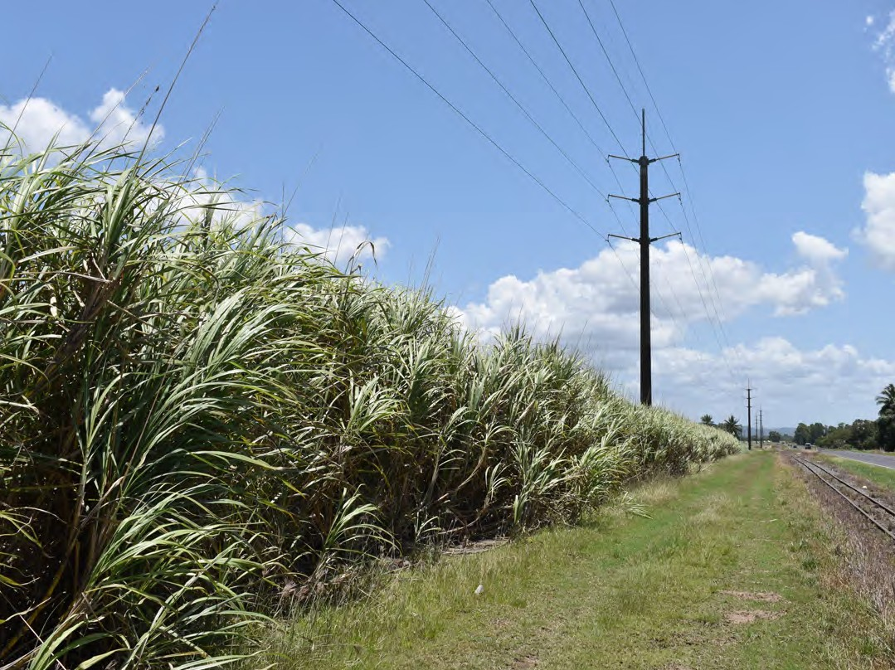

# Machine Safety

Faulty and improperly operated machinery is a major cause of death and injury on farms. Factors which add to the safety risks when operating [farm vehicles, utes, and harvesters](https://www.worksafe.qld.gov.au/safety-and-prevention/hazards/workplace-hazards/agriculture/machinery-and-equipment/farm-vehicles-and-utes) include:

* Unrestrained passengers in trays or on trailers
* Unsupervised children around moving vehicles
* Inexperienced drivers
* Poorly maintained vehicles.

The type of farm enterprise will influence the machinery [related hazards found on farms](https://www.safeworkaustralia.gov.au/system/files/documents/1711/general-guide-for-managing-the-risks-of-machinery-in-rural-workplaces_0.pdf), but they have some common features. They may be grouped as hazards arising from: mechanical energy, noise, electrical energy, heat hazards, vibration, chemical exposure and ergonomic problems.

The most acute and serious injuries and indeed, death occur from the mechanical and electrical hazards. Chemical hazards may result in death or chronic illness. Noise, heat, vibration and ergonomic hazards can result in less severe injury or chronic injury. Farm machinery safety assessments should look at all possible hazards from machinery.

Assessments need to consider the machine, the environment in which it is used, the machine operator and the interaction between all of these.

#### **Operating Machinery**

Operator manuals and safety instructions must be accessible for all operators. A skills assessment should be conducted for new and existing workers to ascertain their competency to operate machinery and vehicles in a safe manner.

When operating any plant or machinery, the operator must take care of and watch for other vehicles and traffic. A safety check should be undertaken prior to starting any machine, including checking the level and condition of fuel, oil, water, transmission fluid, tyres, brakes, and guards. Additionally, check that all fittings are in clean and working order (headlights, reflectors, windscreens, and rear-view mirrors). When leaving a machine with a running engine, ensure that equipment is disengaged, the vehicle is in park, and the handbrake is engaged. Keep in mind the location of overhead power lines when using and moving tall machinery.

#### **Maintenance**

Any malfunction or condition should be reported to the site manager/supervisor and the machinery should not be used until repaired. This includes missing or damaged guards, or where exposed moving parts are causing a safety hazard. If a guard is removed for machinery maintenance or to clear a blockage, it must be replaced before the machine is restarted. If working under raised equipment or implements, ensure adequate supports and chocks are used.

All equipment should be serviced and maintained according to the manufacturer’s specifications. Maintenance record forms should be completed for all services and these forms should be appropriately filed.

The [Guide to Machinery and Equipment Safety](https://www.worksafe.qld.gov.au/__data/assets/pdf_file/0011/20306/guidetomachinery-equipmentsafety.pdf) can help employers and workers comply with duties under the *Work Health and Safety Act 2011*.

# Quad Bike Safety

[Quad bikes](https://www.safeworkaustralia.gov.au/safety-topic/hazards/quad-bikes) (also known as ATVs) are a major cause of death and injury in agricultural workplaces. This risk increases when the bike is travelling at high speeds, is crossing slopes, is towing an attachment, is traveling over uneven ground or has an unstable load. Though quad bikes can be useful, they might not always be the right vehicle for the job. Due to

their light weight and high centre of gravity, there is a high potential for roll over. PCBUs must ensure that quad bikes are safe to use for the situation and that the rider has undertaken proper instruction and training.

For more information, see the following links:

* [https://www.worksafe.qld.gov.au/safety-and-prevention/hazards/workplace-hazards/agriculture/machinery-and-](https://www.worksafe.qld.gov.au/safety-and-prevention/hazards/workplace-hazards/agriculture/machinery-and-equipment/quad-bikes) [equipment/](https://www.worksafe.qld.gov.au/safety-and-prevention/hazards/workplace-hazards/agriculture/machiner)[quad-bikes](https://www.worksafe.qld.gov.au/safety-and-prevention/hazards/workplace-hazards/agriculture/machinery-and-equipment/quad-bikes)
* [https://www.safeworkaustralia.gov.au/quadwatch](https://www.safeworkaustralia.gov.au/safety-topic/hazards/quad-bikes)
* <https://farmsafe.org.au/safety-standard-for-quads>

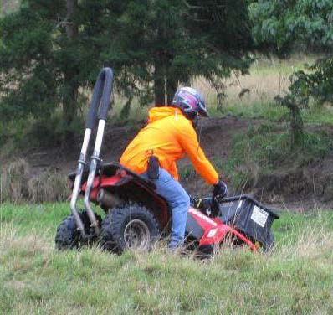

# Workshop Safety

One of the most important issues to consider when planning for safety around the farm workshop is the overall plan and layout of the various sections in relation to each other. Smooth flow of work and machinery and equipment is not only efficient, but is generally safer for workers, contractors, and other bystanders. The safety of people should be ensured in planning and organising traffic flow in and around the workshop.

There are several specific work environment hazards in many workshops that commonly pose risk of injury or illness. When identifying hazards, you should think about the activities that may be conducted in the workshop and observe how items in the plant are being used. These risks must be eliminated or controlled to ensure the health and safety of workers and to comply with WHS regulations

Hazards identified with work in the farm workshop include:

* Poor workshop design and layout
* [Electricity](https://www.worksafe.qld.gov.au/safety-and-prevention/hazards/electricity)
* [Welding](https://www.worksafe.qld.gov.au/safety-and-prevention/hazards/hazardous-exposures/welding)
* [Oxyacetylene welding and cutting](https://www.google.com/url?sa=t&rct=j&q&esrc=s&source=web&cd&ved=2ahUKEwiljbuHy-PxAhV-ILcAHUXJDcEQFnoECAIQAA&url=https%3A%2F%2Fworksafe.tas.gov.au%2F__data%2Fassets%2Fword_doc%2F0008%2F540467%2FSWP_Welder_Oxy-Fuel_Gas_AS563.doc&usg=AOvVaw3XFJtpGSjZx1oJiebgoTPz)
* [Grinding](https://www.safework.sa.gov.au/workplaces/plant-tools-and-vehicles/angle-grinders)
* [Using power and hand tools](https://www.safeworkaustralia.gov.au/safety-topic/hazards/electrical-safety/managing-risks)
* [Battery charging](https://www.safework.sa.gov.au/workplaces/chemicals-substances-and-explosives/lead-acid-batteries)
* [Tyre changing](https://www.worksafe.qld.gov.au/safety-and-prevention/hazards/workplace-hazards/transport/safety-with-tyre-fitting)

The types of injury range from death, serious injury requiring hospitalisation and down time, to “nuisance” injury that stops work for a short time or makes work slower and reduces productivity.

The [Managing the Risks of Plant in the Workplace](https://www.worksafe.qld.gov.au/__data/assets/pdf_file/0020/72641/managing-the-risks-of-plant-in-the-workplace-cop-2021-1.pdf) Code of Practice should be reviewed, which references legal requirements under the *WHS Act*.

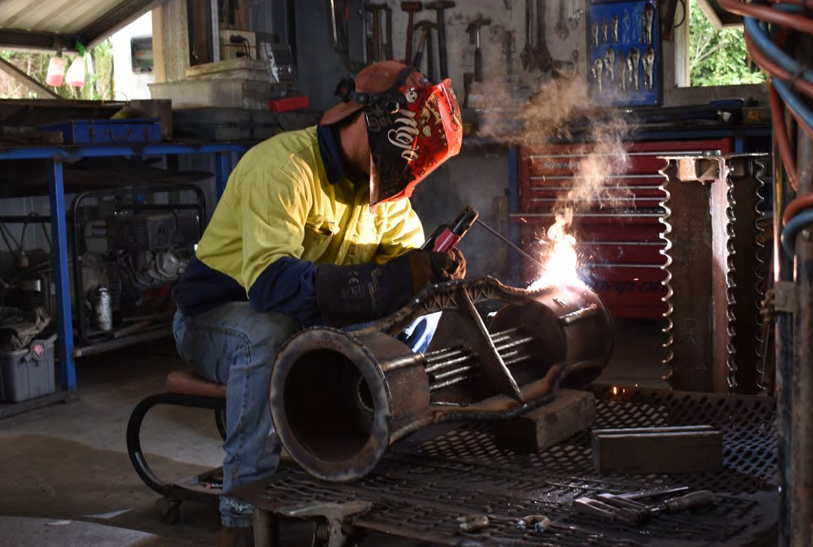

# Cane Firing

#### **Cane land adjoining cane land**

Burning cane in preparation for harvest continues to be an integral and essential part of farming operations for the majority of cane growers.

Under the *Queensland Fire and Rescue Service Act 1990*, special provisions apply to the burning of sugarcane, tops and trash in those situations where a grower's Cane Production Area (CPA) is bordered on every side by other cane land.

Before commencing cane firing, please review the most current [Cane Burning Notification](https://www.qfes.qld.gov.au/sites/default/files/2021-04/QFES-InfoSheet-CaneBurningNotification.pdf).

The QFRS Commissioner's Notification which reflects these special provisions permits growers to light fires for the purpose of burning sugarcane, tops or trash provided that:

* No burning takes place between 10 am and 2 pm
* Adequate precautions are taken to prevent the spread of fire
* The burning takes place in accordance with recognised industry practice
* Where a fire is lit for the purpose of burning tops or trash, such tops or trash are raked at least 10 metres from any headland, standing cane or other flammable material
* Burning takes place within those regulated times set by the local Cane Supply Agreement (subject to no burning between 10 am and 2 pm)
* Where a local Cane Supply Agreement does not regulate times when burning may be carried out, then such burning must take place at a time when sugarcane, tops or trash are normally burnt in the local area (again subject to no burning between 10 am and 2 pm).

#### **Cane land adjoining non-cane land**

Where a grower’s CPA adjoins a neighbour's property which is non-cane land then the grower, wishing to burn sugarcane, tops or trash, must obtain a seasonal permit to burn from the local Fire Warden. The grower need only make a single application to cover the whole season.

#### **Notification to neighbours**

A requirement for all fire permit applications is that the grower must notify all adjoining neighbours whose lands are non-cane land, either verbally or in writing, at the time when applying to the local Fire Warden for the fire permit whether it is a seasonal or one-off permit to burn. Also, before actually burning cane, tops or trash the grower must notify the neighbour whose land immediately adjoins the block of cane or the block upon which tops or trash are to be burnt. This notice can be verbal with the neighbour being advised at least two hours before burning takes place or a minimum of 12 hours notice where the neighbour is advised in writing by the grower.

#### **Smoke management**

Smoke from cane fires and particularly tops and trash fires, needs to be managed carefully in order to address community concerns such as nuisance to neighbours, perceived health hazards, the potential for reduced visibility on roadways which might create a safety hazard and perceived environmental greenhouse effects.

Note: When a fire is lit for the purpose of burning tops or trash, such tops or trash must be raked at least 10 metres from any headland, standing cane or other flammable material.

#### **Offence and general penalty**

Failure to comply with any provisions of the *Fire and Rescue Service Act* is an offence. Penalty provisions including fines and/or imprisonment are prescribed under the *Act*.

Non-observance of the legislative provisions is likely to result in prosecution and adversely impact upon the protection afforded to the cane grower authorised to light the fire.

#### **Permit not required**

A permit to burn cane, tops or trash does NOT have to be obtained where a cane grower's CPA land is separated from the neighbour's non-cane land by a roadway, watercourse or fire break which is at least 10 metres wide and which is clear of vegetation and flammable material.

# Confined Spaces

Confined spaces can be dangerous places to work as they are usually not designed for work activities. Most confined spaces have poor ventilation allowing the development on hazardous atmospheres. The risk of working in confined spaces include:

* loss of consciousness, impairment, injury or death due to the immediate effects of airborne contaminants
* fire or explosion from the ignition of flammable contaminants
* difficulty rescuing and treating an injured or unconscious person
* asphyxiation resulting from oxygen deficiency or immersion in a free-flowing material, such as liquids, grain, sand, fertiliser or water.

If you have confined spaces on your farm you must follow these rules for safe working:

* Avoid working in confined spaces whenever possible e.g. doing work outside
* Follow a safe system of work if working inside
* Make appropriate arrangements for rescue in an emergency.

The [Confined Spaces Code of Practice](https://www.safeworkaustralia.gov.au/system/files/documents/1705/mcop-confined-spaces-v1.doc) is a practical guide to achieving the standards of health, safety and welfare required under the *WHS Act* and the Work Health and Safety Regulations (the WHS Regulations) for confined spaces.

# Working Alone

Working alone increases the risk of jobs on the farm. It is important that [remote and isolated workers](https://www.safeworkaustralia.gov.au/safety-topic/hazards/remote-and-isolated-work) have access to facilities such as toilets, drinking water, first aid, eating facilities, and personal storage. Ensure that those who are working alone have access to an effective means of communicating to emergency services.

For more information on risk management for working alone, see section 4.2 of the [Managing the work environment](https://www.safeworkaustralia.gov.au/system/files/documents/1901/code_of_practice_-_managing_the_work_environment_and_facilities.pdf) [and facilities](https://www.safeworkaustralia.gov.au/system/files/documents/1901/code_of_practice_-_managing_the_work_environment_and_facilities.pdf) Code of Practice.

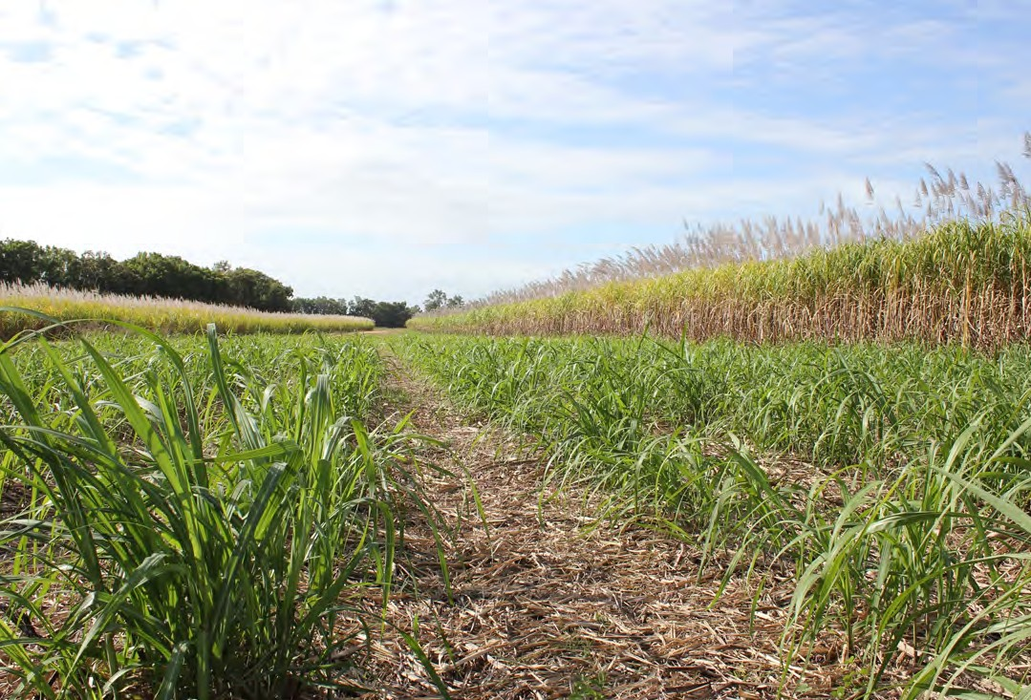

# Contractors

Health and Safety should be a key criterion in the selection of [contractors](https://www.worksafe.govt.nz/topic-and-industry/agriculture/keeping-safe-on-farms/contractors-on-farms/), and steps should be taken to ensure that contractors are competent in health and safety. PCBUs should ensure that risks of farm work are reasonably managed, including any risks form previous work carried out on the farm, and that farm sites are safe for everyone including contractors.

The job should be discussed and agreed upon prior to the commencement of work. Requirements and contractor’s responsibilities for health and safety should be in writing. Contractors should be made aware of work safe procedures in advance and be provided with cite information prior to commencing the job. Appropriate action should be taken if contractors are not working safely. When a job is finished, review how it went including health and safety performance of the contractor.

For more information see page 19 of [Serious About Farm Safety](https://www.worksafe.qld.gov.au/__data/assets/pdf_file/0019/20197/5564-serious-about-farm-safety.pdf).

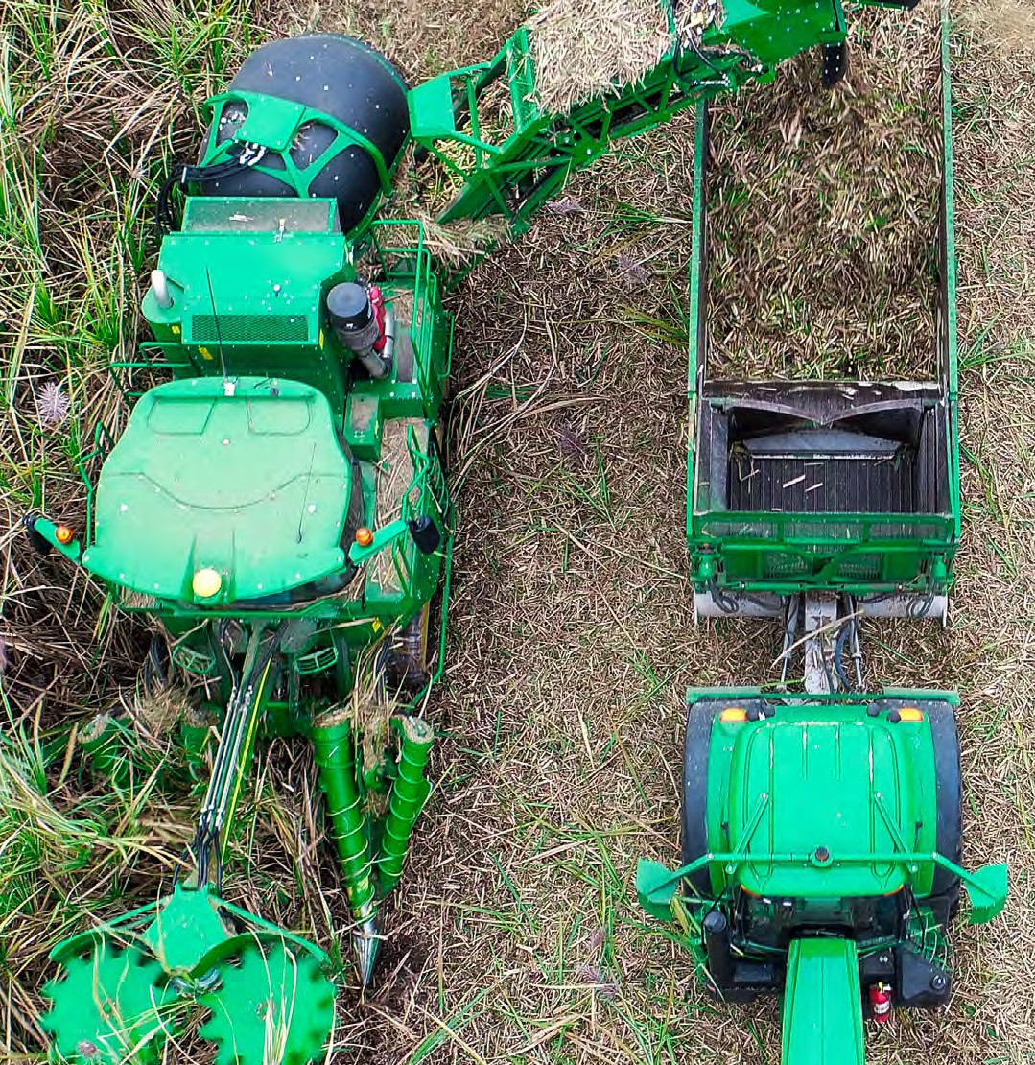

# Sexual Harassment

Sexual Harassment is a workplace hazard which often results in psychological and physical harm. Businesses and organisations are responsible for managing the health and safety risks of sexual harassment. Sexual harassment is defined as any unwelcome sexual advance, request for sexual favours, or conduct of a sexual nature which might lead to offence, humiliations, or intimidation. The [Guide for Preventing Workplace Sexual Harassment](https://www.safeworkaustralia.gov.au/sites/default/files/2021-06/Guide%20for%20preventing%20workplace%20sexual%20harassment.pdf) has been developed for PCBUs to prevent and respond to sexual harassment in the workplace.

See Policy: Sexual Harassment page 46 for more detail.

# Mental health

Psychological health and safety is as important as physical health and safety. Developing a mentally healthy workplace has many benefits including, but not limited to:

* Decreasing work-related injuries and illness
* Thriving workers
* Increases in productivity
* Decreases in absenteeism
* Increases in engagement and job satisfaction.

Psychosocial hazards such as bullying, stress, fatigue, and violence can also impact mental health. The [Mentally Healthy](https://www.worksafe.qld.gov.au/safety-and-prevention/mental-health/mentally-healthy-workplaces-toolkit)  [Workplaces Toolkit](https://www.worksafe.qld.gov.au/safety-and-prevention/mental-health/mentally-healthy-workplaces-toolkit) provides practical tools and resources that employers, managers, and leaders can access.



# Emergencies

While your health and safety program aims to reduce the likelihood of an accident occurring there will be times when things go wrong. Managing work-related incidents and injuries is a legislative requirement and is an important part of minimising loss and disruption to your business.

## Emergency Procedures

Plan for emergencies before they arise. Consider the type of emergency situations that your business could be exposed to: fire, explosion, computer malfunction, chemical spill, flood, medical emergency, machinery or motor vehicle accident, robbery or violence. Natural disaster emergencies may also exist including: cyclones, bushfires, and extreme thunderstorms. Develop plans and procedures on how to respond quickly and safely in such emergencies.

Once you have developed your emergency plan, practice it regularly (every 6 months) to ensure that everyone knows how it operates and include in the induction of new staff and contractors. Procedures should be clearly displayed for all employees to see.

## First Aid

The extent and type of first aid arrangements for your workplace should be based on the hazards and level of risk determined in the risk assessment process. Ensure the appropriate first aid equipment, facilities and trained personnel are available and readily accessible. Consideration should be given to:

* Type of activities, size and layout of the workplace
* Proximity to medical services
* Number and distribution of staff including arrangements such as shift work and overtime.

Every workplace has a legal responsibility for ensuring adequate first aid provisions, and the number of first aiders/first aid offices is determined by the type and nature of the workplace. Please see the [First Aid in the Workplace- Code of](https://www.worksafe.qld.gov.au/__data/assets/pdf_file/0019/72631/first-aid-in-the-workplace-cop-2021.pdf) [Practice](https://www.worksafe.qld.gov.au/__data/assets/pdf_file/0019/72631/first-aid-in-the-workplace-cop-2021.pdf) for further information.

[St. John Ambulance](https://stjohn.org.au/first-aid-training) and [Queensland Ambulance Services](https://bookings.qld.gov.au/services/firstaid/) provide certified first aid training in Queensland.

## Investigating and Reporting

Accidents are not just bad luck or unpredictable - in most cases they occur as a result of a chain of events and a failure of one or more links in that chain. Investigating accidents helps you find out what went wrong, why it happened and, if a control measure was in place, why it failed.

A ‘near miss’ or dangerous occurrence should be treated as a warning sign and should also be thoroughly investigated. Workers should be encouraged to report these potential accidents in the same way that they are encouraged to report hazards. Identifying what went wrong and why and taking action to ensure that the same situation is not repeated, is an essential part of managing safety in your workplace.

Part 12 of the *Workplace Health and Safety Regulations 2011* requires employers to notify *Workplace Health and Safety Queensland* of any workplace death or serious injury, work caused illness or any incident that could have caused death or serious injury (dangerous occurrence). [An Incident Notification report form](https://ols.workcoverqld.com.au/ols/public/incident/registration.wc) for this purpose is available from WorkCover Queensland. The WHS Regulation requires that this approved form be completed and kept for your records.

Part 14 of *The Electrical Safety Regulation 2013* (ES Regulation) requires employers to notify the *Electrical Safety Office* or *Workplace Health and Safety Queensland* in the approved form for any serious electrical incident or dangerous electrical event. The ES Regulation requires this record to be kept for your records.

For all incidents, this form must be lodged within 24 hrs of the relevant employer becoming aware of the

incident. In the case of death, as well as lodging the approved form within 24 hrs, the relevant employer must notify by the quickest possible means after he or she becomes aware of the death.

Counselling services should be offered to workers who have witnessed a serious accident or experienced a violent incident.

***Emergency Information Signs - Indicate location or direction to emergency facilities***



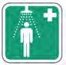

*First aid*

*Eyewash*

*Emergency (safety) shower*



*Stretcher*

*Emergency telephone for first aid or escape*

# COVID-19 and the Workplace

## COVID-19 Risk Management

The [COVID-19 pandemic](https://farmhub.org.au/covid-19/) has impacted the way we conduct business and manage health and safety risks. COVID-19 is no different to any other workplace hazard and should be addressed as you would any other risk via a risk assessment. The risk assessment should be planned, systematic and cover all reasonably foreseeable hazards and associated risks. The PCBU has a responsibility to keep workers safe from the risk of COVID-19 at the farm and to know which actions to take if someone becomes ill.

The exposure of your workers and/or customers/clients to COVID-19 is a foreseeable risk that must be assessed and managed in the context of your operating environment.

A [risk assessment](https://covid19.swa.gov.au/covid-19-information-workplaces/industry-information/agriculture/risk-assessment) will assist to:

* Identify which workers are at risk of exposure
* Determine what sources and processes are causing the risk
* Identify if and what kind of ***control measures*** should be implemented, and
* Check the effectiveness of existing ***control measures.***

The [National Farmers Federation COVID-19 (NFF) Workplace Guide](https://farmhub.org.au/covid-19/#%3A~%3Atext%3DInformation%20for%20Employers-%2CNFF%20COVID-19%20Workplace%20Guide%2C-Download%20the%C2%A0NFF) provides basic advice to help manage the impact of COVID-19 on farming workplaces, and facilitate thinking and decision making. CANEGROWERS have also produced a [Sugarcane Farm COVID-19 Guide](http://www.canegrowers.com.au/icms_docs/317139_canegrowers-sugarcane-farm-covid-19-guide.pdf) to add to the NFF guide.

Actions should be taken to ensure good hygiene, social/physical distancing, and cleaning in the workplace.

#### **Good Hygiene**

The main method of transmission of COVID-19 is through contact of respiratory droplets produced by a cough or sneeze from an infected individual. Airborne transmission can also occur in crowded or poorly ventilated places. Practicing [good](https://covid19.swa.gov.au/covid-19-information-workplaces/industry-information/agriculture/hygiene) [hygiene](https://www.safeworkaustralia.gov.au/covid-19-information-workplaces/industry-information/agriculture/hygiene) is a key strategy to protect yourself and workers from exposure to COVID-19.

Consider:

* Worker and visitor hygiene: Enhance good hygiene outcomes by developing infection control policies, training workers on handwashing, providing informational tools, and setting expectations. Put in processes to review the implementation of hygiene measures and ensure they are being followed.
* Providing adequate facilities: Ensure hygiene facilities are in good working order, are clean, and are safe to use. Consider if you have an adequate number of hand washing and drying stations, and sanitiser stations. Providing paper towels is preferred over hand dryers to reduce risk of transmission.

#### **Social/Physical Distancing**

Social/physical distancing can help to reduce the risk of transmission of COVID-19. Current health advice recommends that people maintain a physical distance of 1.5 metres, but this may change, and it is recommended that you review the most recent [NFF COVID-19 updates](https://nff.org.au/covid-19/) as they are published and follow public health measures.

It is your duty to implement physical distance measures in your workplace. You must comply with your state or territory’s public health directions that apply to your business. You may need to consider re-arranging your workplace to ensure that workers can maintain social distancing of 1.5 metres. For more information regarding the implementation of physical distancing in your workplace, please see:

* [https://www.safeworkaustralia.gov.au/covid-19-information-workplaces/industry-information/agriculture/physical-distancing](https://covid19.swa.gov.au/covid-19-information-workplaces/industry-information/agriculture/physical-distancing)

#### **Cleaning and Disinfection**

[Cleaning and disinfecting](https://covid19.swa.gov.au/covid-19-information-workplaces/industry-information/agriculture/cleaning) are important factors in managing the risk of COVID-19. Workplaces should be cleaned daily, with detergent and water. Following cleaning, surfaces should be disinfected. Disinfecting is a separate process from cleaning and requires the use of chemicals to kill germs. For more information on cleaning and disinfecting processes, see [Safework Australia’s COVID-19 Information for Workplaces](https://covid19.swa.gov.au/covid-19-information-workplaces).

## Seasonal Workers

On 3 November 2020 Queensland Health issued a ‘[Seasonal Workers Health Management and International Quarantine](https://www.health.qld.gov.au/system-governance/legislation/cho-public-health-directions-under-expanded-public-health-act-powers/seasonal-workers)  [Plans Direction (No.2)](https://www.health.qld.gov.au/system-governance/legislation/cho-public-health-directions-under-expanded-public-health-act-powers/seasonal-workers)’. This direction required businesses that employ seasonal workers to have a *health management plan* and for those international workers who have not completed quarantine in government-nominated accommodation to have an *endorsed international Pacific Labour Scheme (PLS)/Seasonal Worker Program (SWP) quarantine plan*.

The [Workplace Health Management Plan Template](https://www.health.qld.gov.au/__data/assets/word_doc/0039/959880/health-management-plan-template-workplace.docx) can help you to reduce the risk of transmission of COVID-19 from incoming workers. You should consider:

* Health screening prior to the worker commencing work
* Health screening daily prior to commencing work
* Reducing the risk of transmission at the work site by ensuring good hygiene, social/physical distancing, cleaning and disinfecting
* Gathering and keeping records of staff documentation.

## Vaccinations

The [Australian government](https://www.health.gov.au/initiatives-and-programs/covid-19-vaccines/getting-vaccinated-for-covid-19) has committed to providing a safe, effective, and free COVID-19 vaccination to everyone who resides in Australia. The [COVID-19 Vaccines National Rollout Strategy](https://www.health.gov.au/initiatives-and-programs/covid-19-vaccines/getting-vaccinated-for-covid-19/when-will-i-get-a-covid-19-vaccine) determines who is eligible for the vaccine. Regardless of your vaccination status, you still need to practice good hygiene, maintain physical distance, stay home if you are sick and get tested.

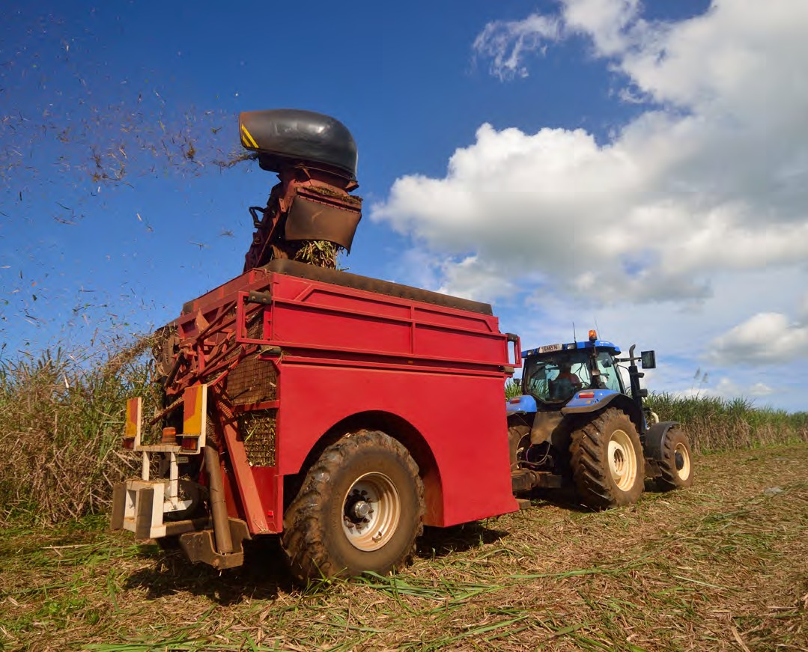

# Workers Compensation

Any person who operates a trade or business and employs workers in Queensland must maintain a current workers compensation policy under the [*Worker’s Compensation and Rehabilitation Act 2003*](https://www.legislation.qld.gov.au/view/html/inforce/current/act-2003-027).

If you engage contractors/subcontractors on a regular and systematic basis, you should contact [Qld Workcover](https://www.worksafe.qld.gov.au/) to discuss the employment arrangement, as these people may also be deemed ‘workers’ under the workers compensation legislation.

#### **Early Intervention and Reporting**

The *Worker’s Compensation and Rehabilitation Act 2003* places emphasis upon ‘early intervention’ to facilitate early and safe return to work for workers having sustained a workplace injury. The process involves early notification of injuries to the employer, and by the employer to *Qld Workcover*.

* As an employer - claim forms on request from an injured worker
* Lodge a completed Employer’s Report form with Qld Workcover within 10 days
* If your worker has lodged their application with you - ensure you have attached their application.

You must:

* Keep a Register of Injuries that is readily accessible to the workers, and which records every injury regardless whether or not a claim is made
* Send an Injury Notification Report to Workplace Health and Safety Queensland within 24 hrs of becoming aware of any incident
* In the case of death, notify Workplace Health and Safety Queensland by the quickest possible means after you become aware of the death
  + Provide compensation for Compensation form
  + Their Worker’s Compensation Medical Certificate/s
  + Their Tax File Number Declaration (if needed)
  + Send in your Employer’s Report within 10 days to your nearest Workcover office.

#### **Rehabilitation and Work Return**

Workplace rehabilitation of injured workers is a requirement under the *Worker’s Compensation and Rehabilitation Act 2003*. Workplace rehabilitation helps injured workers achieve an early return to the workplace.

* Develop a **Return to Work Program** in consultation with your workers, an approved rehabilitation provider and any industrial union representing the workers
* Display the program and a copy of the information summary to the workers
* Take all reasonable steps to provide suitable duties to a worker returning from injury or illness.

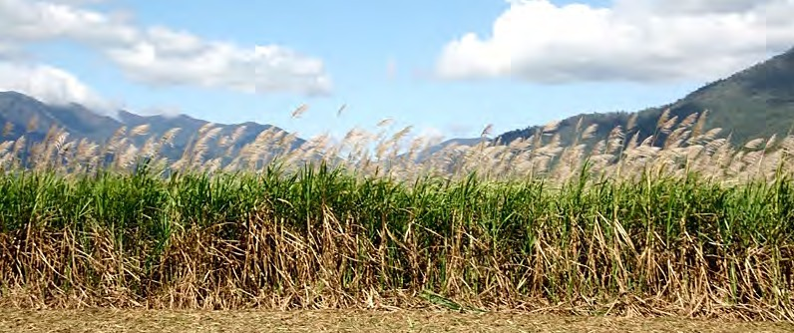

# Appendix 1: Example Policies

A WHS policy is a set of guidelines for your business and your employees to follow to achieve WHS goals. An effective policy will outline what actions employees should take with directions, limits, and guidance for making decisions.

Regardless of the size of your business, clearly set policies can help to guide operations and enhance safety.

The following policies have been provided to you as an example for your business, but you may tailor them to your specific needs or circumstances. For additional help establishing policies and procedures, please see:

<https://www.worksafe.qld.gov.au/safety-and-prevention/creating-safe-work/establishing-policies-and-procedures>

Example Policies include:

* Example Policy: Responsibilities for Workplace Health and Safety
* Example Policy: Workplace Hazard Identification and Audit
* Example Policy: Incident and Injury Reporting
* Example Policy: WorkCover Claims Administration
* Example Policy: Contractors - Occupational Health and Safety Provisions
* Example Policy: Drugs, Alcohol and Fitness for Work
* Example Policy: Bullying and Aggression at Work
* Example Policy: Sexual Harassment
* Example Policy: Working Alone
* Example Policy: Visitors on Farm
* Example Policy: Induction
* Example Policy: Quad bike safety

## Example Policy: Responsibilities for Workplace Health and Safety

**The Purpose** of this document is to outline the various responsibilities to ensure that the « » meets its objectives set out in the Workplace Health and Safety Policy and its subordinate policies, procedures and programs.

The Management of « » ensures that comprehensive and effective health, safety and welfare services are properly implemented, co-ordinated and maintained. This responsibility extends to the provision of appropriate resources in order to achieve continuous improvements in workplace health and safety. A key role is to set and review management objectives to ensure planned results are achieved through integrating health and safety into the operations of the business.

**The Management** of « » shall ensure that appropriate safety services, and preventive programs are developed, maintained and revised. Management is also responsible for the effective rehabilitation of employees.

#### **Policy Statement**

Whilst there are legal obligations for both employers and employees under the *Workplace Health and Safety Act*, it is our commitment to safety at « », which will determine how safe our workplace is.

Having an attitude that “safety in the workplace is paramount” will serve to build morale with the associated benefits of increased productivity and efficiency.

At the « » workplace, the health, safety and welfare of all employees and visitors is of equal importance to all other operational considerations. The employer and employees work together to create a safe working environment and ensure compliance with the *Workplace Health and Safety Act 2011*.

#### **Responsibilities**

The **Employer** responsibilities include;

* To assess established controls and programs for their effectiveness and success and define specific goals for future programs
* To plan strategies, in consultation with employees, to secure improvements in workplace health and safety and rehabilitation
* Ensuring all policies operating in the workplace are implemented and kept up to date
* To promote and provide appropriate safety training
* To support all employees and others in their WHS functions
* To promote a positive health and safety attitude in the workplace
* To provide employees with information and statistics relating to workplace accidents and incidents
* To keep under review and provide information on legislation in order to maintain appropriate policies, procedures and programs
* To maintain an appropriate data base on injuries, compensable disabilities, and rehabilitation and to provide the necessary reporting to Workcover and Division of WHS as prescribed by legislation or for effective injury management
* To remain vigilant to ensure the workplace and work procedures are as far as possible, free from risk to injury, health, and the environment
* To induct new employees and contractors so that they can carry out their duties safely and in accordance with established procedures
* To consistently encourage the early reporting of injuries and conditions
* Investigating accidents, determining how and why they happened, keeping work accident and injury records and reporting to the Division of Workplace Health and Safety where appropriate
* To ensure all those under their control apply their training and that they are complying with established policy and procedure
* To implement appropriate discipline or training for breach of established policy and procedures or standards of performance
* Informing WorkCover Queensland of any compensable injury claims within 28 days of their occurrence
* To ensure the effective and safe return to work of people who have sustained a work-related injury or illness.

#### **Employees**

**Employees** have a responsibility to co-operate with the aims of policies and programs and to follow established procedures. They have specific responsibilities:

* To perform their duties in a manner that preserves personal safety, the safety of other employees and contractors as well as members of the public and the environment
* Taking reasonable care to ensure his/her own health and safety and the health and safety of others at the workplace
* To safely and properly use the farming property entrusted to their care
* To use equipment provided for health and safety purposes and keep the workplace clean and tidy
* Refraining from removing or interfering with any safety guard or safety device
* To carry out instructions given in relation to health and safety
* Complying with instruction from the employer on safety procedures, and as stated on all machinery and chemical containers
* To report any unsafe action or condition immediately, especially if it results in injury
* To ensure they are not, by the consumption of alcohol or a drug, in such a state to endanger their own safety or the safety of another person
* Identifying safety hazards and associated risks and report those to the employer or site supervisor. Hazards such as slippery surfaces, broken floors, sharp protruding objects, exposed belts, open flywheels, chemical storage, fire hazards, machinery, or vehicles in need of repair or maintenance need to be reported
* To participate in consultation in a positive manner in an effort to maintain continuous improvement in health and safety.

**We expect contractors:**

* To be responsible for the health and safety of ***their*** employees
* To observe and comply with industry best practice and legislative requirements relative to the specific task contracted.

#### **Authorisation**

This instruction takes effect from:

Signed: Date: Document Review Date:

## Example Policy: Workplace Hazard Identification and Audit

#### **Policy Statement**

To ensure that « » meets its responsibilities under the *Workplace Health and Safety Act* and with the objective of continuous improvement in workplace health and safety, it is the policy of the « » to conduct regular inspections and action the findings of those surveys.

While Management has the ultimate responsibility for workplace safety, all employees are expected to participate in actions that support the aims of the continuous improvement process.

#### **Procedure**

Management shall undertake a **yearly** audit of the workplace, using an established checklist. In conducting the inspection, it is suggested that one or more employees accompany Management to assist in identifying and assessing hazards and associated risks in the workplace.

#### **Delegation**

Management may delegate the task of conducting the inspection but shall remain responsible for its findings and implementing corrective actions.

#### **Inspection Process**

The area inspected may be part of, or the whole of the workplace. The inspection should follow a logical and systematic route through the whole area subject to inspection and each item on the checklist considered. The principle of the ‘lowest common denominator’ should apply, so for example, if one area is adequately serviced with suitable fire extinguishers but another area lacking, then the status of **‘ACTION NOW’** should be allocated with the comment made referring to the sub-standard area.

#### **Summary of Responsibilities**

**Management**

* To ensure audits are conducted at agreed intervals
* To execute inspection themselves if it is at all possible
* To agree to an Action Plan with the auditors
* To ensure corrective action is taken
* Auditors
* To apply consistent interpretation of status across all sections being inspected
* To consider what is reasonably practicable
* Employees
* To undertake actions that benefits the continuous improvement process.

#### **Authorisation**

This instruction takes effect from:

Signed: Date: Document Review Date:

## Example Policy: Incident and Injury Reporting

#### **Policy Statement**

It is the policy at « » workplace to document, report and investigate all incidents, accidents and hazards that result in, or have the potential to cause, personal injury, damage to equipment or harm to the environment.

These activities will commence as soon as practicable after an incident occurs or a hazard becomes apparent and shall be undertaken with the objective to prevent a recurrence and to minimise loss or damage.

#### **Policy Objectives**

The aim of this policy is to document unplanned and uncontrolled events and action the findings of investigations to reduce the frequency, severity and cost of incidents and accidents.

It is our policy that all injuries sustained in the workplace, however minor are reported to management.

#### **Definitions**

**An incident** is an unplanned, unexpected event where no damage is done, but in the circumstances ***may*** have resulted in an accident.

**An accident** is an unplanned, unexpected event that results in harm to people, damage to property, or a process loss.

#### **Responsibilities**

Employer is responsible for:

* Providing first aid resources
* Reporting events resulting in injury or death to the Division Of Workplace Health and Safety
* Ensuring all accidents and incidents are reported, investigated and that corrective action is taken. They shall sign each report form as a demonstration of their involvement in the process and endorsement of the proposed corrective action.

Employees are responsible for:

* Reporting all accident and incidents in the first incidence to their immediate superior in writing on the appropriate injury report form, and
* Co-operating in any subsequent investigation process.

#### **Incident and Accident Reporting Procedure**

This procedure has been developed to outline the steps in the process involved in a workplace incident or accident.

* Ensure the appropriate steps are taken to immediately reduce harm by safely controlling the situation. This includes taking the necessary action to protect your-self
* Where bodily injury has occurred, ensure the appropriate First Aid treatment is provided. Assist the person administering first aid by following their instructions
* It may be necessary to involve or advise external Emergency Services or Authorities, and contact with these services shall be at the direction of the person administering first aid or at the direction of the workplace manager or supervisor
* The manager/supervisor shall initiate the recording of the event by completing an accident report form, which will include conducting an investigation to identify causal factors
* The ***employer*** has an obligation under the *Workplace Health and Safety Act* to report any incidence of personal injury resulting in an overnight hospitalisation, serious bodily injury or dangerous event involving an employee. The ***employer*** shall complete an injury report form and notify the nearest office The Department of Industrial Relations, Division of Workplace Health and Safety
* In the case of a fatal injury occurring, the ***employer*** shall notify the Division of Workplace Health and Safety within 24 hours after becoming aware of the incident.

(Note it is the responsibility of the employer to ensure that this function is carried out. Do not assume that other agencies such as the police or ambulance will always carry out this function.)

All employees have an obligation to participate in the immediate reporting of unsafe acts, near misses, unsafe conditions or work-related injury or illness.

#### **Authorisation**

This instruction takes effect from:

Signed: Date: Document Review Date:

## Example Policy: WorkCover Claims Administration

#### **Policy Statement**

It is the policy of « » to manage its Workers Compensation claims in a timely manner in accordance with the requirements of the *Workers Compensation and Rehabilitation Act 2003* through WorkCover Queensland. No employee shall be subject to prejudice or discrimination because they claim workers compensation benefits.

#### **Policy Objectives**

To ensure employees who sustain a work-related injury or illness are fairly and promptly provided with benefits pursuant to the appropriate *Workers Compensation and Rehabilitation Act 2003*, to administer claims in a cost effective and ethical manner, and to return injured employees to work safely.

#### **‘What is a Claim for Compensation?’**

When an employee suffers an injury or illness as a result of their work activity, they are entitled to fill in a claim for compensation form. This claim form gives the employer written information about the event. A worker would normally ask management for a form, complete as much information as possible and then hand the form to management. The worker receives a copy of the claim form for their own records and they are always entitled to ask Management for a copy from their records.

When a Medical Certificate supports this claim form, then this creates a claim for compensation and must be actioned within certain time frames set out in the *Workers Compensation and Rehabilitation Act 2003*.

#### **Responsibilities**

* **The « » Management** shall continuously review the effectiveness of the injury management process to ensure it meets the needs of the policy
* **Management** shall submit all claims to the relevant insurer as soon as possible, maintain records in a confidential and accurate manner, and comply with the requirements of the *Workers Compensation and Rehabilitation Act 2003*
* Under the *Workers Compensation and Rehabilitation Act 2003* an employer, whose worker sustains an injury for which compensation may be payable must complete a report in the approved form and send it to the nearest office of Work Cover Queensland
* Section (2) states **The Employer** must report the injury within **10 days** after the first of the following happens:
  + The employers knows the injury has been sustained
  + The worker reports the injury to the employer
  + The employer receives Work Cover’s written request for a report
* ***Management*** shall liaise with the employee and the treating medical providers to ensure a safe and timely return to work and assess the suitability of non-medical treatments. It is the responsibility of ***management*** to assist in the development and documentation of return-to-work plans
* ***Management*** shall advise employees of their rights and responsibilities in relation to the Injury Management process, shall maintain constant communication with the employee in relation to their return-to-work program and monitor its effectiveness. They shall also be responsible for identifying opportunities for rehabilitation tasks
* *Employees* have a responsibility to report all injuries, provide medical certificates when absent from work, genuinely participatein rehabilitation, and maintain a high level of co-operation with the injury management process. *The Act* states a worker receiving compensation for an injury must give written notice within 14 days of the workers return to work. The employee must be informed of their responsibility to maintain regular communication with management about their treatment and progress. In certain circumstances, the non-reporting of their progress or whereabouts will put their claim at risk and may result in non-payment of benefits. They are encouraged to keep management informed of the status of their claim and supply medical certificates when required
* ***Employees***’ responsibility extends to advising the treating medical practitioner to constantly review the suitability of medical treatments to assist in returning the employee to safe work in a timely manner.

#### **Medical Expenses**

All originals of medical accounts must be forwarded to management as soon as possible for payment or to claim from

WorkCover. Where the employee makes payment personally, then this information must be communicated so that the employee can be reimbursed.

#### **Reporting Claims to WorkCover Queensland**

For instructions regarding reporting claims to WorkCover, visit: [https://www.worksafe.qld.gov.au/claims-and-](https://www.worksafe.qld.gov.au/claims-and-insurance/compensation-claims/make-a-claim) [insurance/compensation-claims/make-a-claim](https://www.worksafe.qld.gov.au/claims-and-insurance/compensation-claims/make-a-claim)

#### **Claims Administration Checklist**

|  |  |  |
| --- | --- | --- |
| 1. Has the employee been asked to fill out a claim form? | Yes | No |
| 2. Has management signed and dated the claim form? | Yes | No |
| 3. Have you given the employee a copy of the form? | Yes | No |
| 4. Has the employee provided a medical certificate? | Yes | No |
| 5. Has the incident report form been completed? | Yes | No |
| 6. Has the employers report form been completed? | Yes | No |
| 7. Have all forms been sent to management? | Yes | No |
| 8. Have you explained that ‘no form equals no pay’? | Yes | No |
| 9. Have you explained that management will be advised if the  claim is accepted or rejected, and a copy will be sent to the employee? | Yes | No |
| 10. Have you explained that the payment of workers compensation will be made by bank credit from the employer? | Yes | No |
| 11. Have you explained that the employee must attend all medical appointments or that failure to do so may result in payments being suspended? | Yes | No |
| 12. Have you explained that medical certificates must be provided for any absence from work? | Yes | No |
| 13. Have you explained that the employee must comply with the doctors’ instructions AND genuinely attempt duties made available? | Yes | No |
| 14. Have you explained that if employees move interstate without consent, they may suffer loss of compensation benefits? | Yes | No |
| 15. Have you advised them of the process if they are dissatisfied with any aspect of the claim? | Yes | No |

***Authorisation***

This instruction takes effect from:

Signed: Date: Document Review Date:

## Example Policy: Contractors - Occupational Health and Safety Provisions

*Note: It is good practice to ensure that the PCBU and the contractor both have signed copies of this policy*

#### **Policy Statement**

Contractors shall refer to and comply with « » workplace health and safety policy together with the following;

* Contractors’ acceptance of our conditions and order will be deemed full and unconditional acceptance of « » health and safety policy and procedures
* Contractors must ensure that safe working methods are adopted, and that all appropriate equipment and machinery is used to avoid injury, damage and wastage
* All contractors are required to sign the declaration appended to this document prior to undertaking work in the workplace.

#### **General**

All contractors will be required to comply with workplace health and safety policy and procedures, whilst carrying out work in a workplace controlled by the contractor or if engaged to perform work on behalf of « ».

When requested, contractors will be expected to produce a copy of their own occupational health and safety policy on acceptance of our order and identify the person responsible within their own organisation for health and safety.

Contractors will be held responsible for any costs incurred to « », which result from their adoption of unsafe work practices and/or use of unsafe plant and equipment.

#### **Safety Equipment**

* The contractors’ employees must be made aware of specific areas where safety equipment and/or personal protective clothing are to be worn or used
* The responsibility to provide all appropriate safety protective clothing and/or equipment, together with training and information will rest solely with the contractor
* Contractors’ personnel will be expected to wear, or use such items when required to do so by Management or in accordance with the requirements of the safety procedures.

#### **Systems of Work**

* It is the responsibility of the contractor to ensure that all work is carried out in accordance with *The Queensland Workplace Health and Safety Act 2011*, the subordinate Workplace Health and Safety Regulations 2011, specified Australian Standards and approved Codes of Practice and Advisory Standards relating to occupational health and safety
* Contractors are not permitted to alter, or interfere with any plant, tool or equipment owned or on hire to « » unless authorised in writing by Management
* Whilst in the workplace, scaffolding or other access equipment must be inspected by the contractors “Competent Person” to ensure that it is in full compliance and maintained in accordance with the requirements of the *Queensland Workplace Health and Safety Act and Regulations*
* Materials, articles or substances, brought into a workplace, which have any health, fire or explosion risk must be used in accordance with all current regulations, and full details must be given to Management/ Supervisor prior to commencement of all work.

#### **Maintenance**

* All equipment, tools and plant introduced by contractors must be properly maintained, and in good general working order, with any necessary guards and/or safety devices in place
* Power tools and all electrical equipment introduced by contractors must conform to the relevant Queensland regulations
* Contractors will be required to maintain workplaces in a clean and tidy condition with debris, waste materials and surplus equipment, removed and cleared as work proceeds. Work areas and access to work areas must be cleared at the end of each working day
* Hazardous substances and waste shall be disposed of in accordance with the MSDS and label requirements for the particular product and in accordance with the policy on the management of hazardous substances.

#### **Communication**

* Any accident or injury sustained to any contractors’ employees must be reported immediately to Management
* Whilst present on the farming property, contractors are to comply with any instructions issued by Management relating to workplace health and safety.

#### **Safety and Risk Control**

* Where required or requested, and prior to commencing the work, contractors will submit to « » a safety management plan, setting out the arrangements and proposed methods of work to safeguard the health and safety and welfare of all personnel on the premises
* Management will consult with and support the role and function of elected Health and Safety Representatives of a Contractor. The elected Health and Safety Representative will be permitted to carryout periodic inspections of the workplace
* Contractors will be informed by Management of hazards, defects, or any other workplace health and safety matter noted, and when appropriate will be expected to take immediate remedial action to rectify any unsatisfactory situations.

#### **Enforcement Notices (Division of Workplace Health and Safety)**

* Contractors shall immediately inform Management in the event of either an Improvement, or Prohibition Notice being issued by the Division of Workplace Health and Safety and must cease any specified work activities, until the notice is cancelled or complied with.

#### **Compliance Proof**

* All contractors will provide proof of workers compensation insurance, public liability insurance, and produce appropriate licensing for the work to be undertaken.

#### **Sub-Contractors**

* The same conditions apply to sub-contractors and their employees as to Contractors and their employees.

#### **Contractor Induction Checklist**

**Prior to Arriving on Site**

The Contractor has supplied a copy of their Workers Compensation registration

The Contractor has provided either a copy of their Public Liability insurance renewal certificate or details of the Insurer and Policy Number.

The Contractor has provided written details of their safety procedures.

The contractor and their staff have appropriate licenses or permits for the type of work to be done and plant to be operated.

The Contractor has provided copies of Material Safety Data Sheets (MSDS) for any substances they will be using.

**On Arrival at Site**

Provided with a copy of the “Health and Safety Policy”. Introduced to Management and other key staff Arrangements made regarding the use or purchase of fuel Arrangements made regarding the use of amenities

Use of workshop explained

Requirements of Personal Protective Equipment explained

Use of electrical equipment explained and the need for Residual Current Devices. Fire protection arrangements.

Rules and procedures explained regarding Hazardous Substances and Explosives. Prohibited or restricted areas explained

Contractor understands the rules regarding alcohol and drugs.

Location and access of drinking water explained. Use of telephone explained

Bringing personal pets and animals onto the site.

Emergency procedures explained, including Emergency Services Contact numbers.

#### **Specific Responsibilities of Contractors**

To provide safe systems of work for their staff and others To keep work area as clean and tidy as possible

To report any injuries to staff as soon as reasonably practicable. To provide First Aid kits for the use of their staff.

To provide washing and toilet facilities for their staff To provide washing and toilet facilities for their staff To provide drinking water for their staff.

To report any damage or loss to property, equipment, and material to Management as soon as possible. To avoid environmental damage, including waterways and soil.

To dispose of waste in an appropriate manner.

#### **Contractor Agreement**

I/We

Name:

Company:

Address:

Post Code:

Agree to comply with the provisions set out in the document “Provisions for Contractors” in respect to all work activities and operations undertaken on the premises, or in work areas under the management and control of « »

For and on behalf of the Contractor:

Signed: Position:

For and on behalf of Management

Signed: Dated this Day of 20

Document Review Date:

## Example Policy: Drugs, Alcohol and Fitness for Work

#### **Policy Statement**

It is the policy of « » that all employees and contractors shall report for work in a condition that does not endanger their own safety or the safety of any other person at work, and that employees and contractors shall maintain an acceptable level of performance throughout the working day.

Management maintains the right to refuse work or entry to a work site to any employee, contractor, or client who, in the opinion of the Management, is in an unfit state to perform safe work.

#### **Responsibilities**

To assist in meeting this policy, Management, its employees, contractors and clients shall observe that:

* No alcohol shall be consumed or permitted on site at any time unless expressly authorised by Management
* No illegal drugs shall be consumed or permitted on site; if in the opinion of Management, an employee is at any time in an unfit state to work safely, they may be assigned other duties or sent home
* Employees who are taking any medication that may affect their ability to work safely are encouraged to make management aware of the circumstances so that appropriate duties may be assigned
* n some circumstances it may be necessary for appropriate disciplinary action to be taken in accordance with established procedure, and
* If in the opinion of the site supervisor, a client is perceived to be under the influence of alcohol or drugs and there is likelihood the person may fail to ensure the workplace safety of themselves or others, then that person may be refused admittance to the site. All such actions must be immediately reported to Management.

#### **Authorisation**

This instruction takes effect from:

Signed: Date: Document Review Date:

## Example Policy: Bullying and Aggression at Work

#### **Policy Statement**

« » is committed to ensure the workplace health and safety of its employees. Aggressive behaviour in any form is unacceptable and needs to be dealt with appropriately.

#### **Definitions**

* “[Aggression](https://www.safeworkaustralia.gov.au/safety-topic/hazards/workplace-violence-and-aggression)“ includes: verbal abuse, physical violence against an individual in the form of hitting, slapping, spitting, scratching, pinching, kicking, threats of violence against objects, such as kicking or throwing property
* Aggressive behaviour by employees will be treated as a breach of health and safety requirements. That is, employees will be given formal warnings and if the unacceptable behaviour continues, may have their employment terminated
* Some forms of aggressive behaviour can be considered to be assault. Should any employee be considered to be the perpetrator of an assault, they will instantly be dismissed from their employment with « ». Any formal complaint lodged by an employee will be fully investigated by Management and where appropriate Police intervention will be sought
* “[Workplace bullying](https://www.safeworkaustralia.gov.au/safety-topic/hazards/bullying)” is repeated and unreasonable behaviour directed towards a worker or group of workers that creates a risk to health and safety
* Bullying can take different forms including psychological, physical or even indirect—for example deliberately excluding someone from work-related activities. It can be obvious, and it can be subtle, which means it’s not always easy to spot.

#### **Employer’s Responsibilities**

* Investigate incidents involving aggression and take appropriate preventive action
* Debrief employees who are involved in an aggressive or bullying incident and ensure that follow up action is taken
* Apply appropriate disciplinary procedures if applicable.

#### **Employee’s Responsibilities**

* Report all incidents involving aggression and bullying.

#### **Authorisation**

This instruction takes effect from:

Signed: Date: Document Review Date:

## Example Policy: Sexual Harassment

### What is sexual harassment?

*The Human Rights Act 1993* defines sexual harassment as any unwelcome or offensive sexual behaviour that is repeated, or is of such a significant nature to have a harmful effect, or which contains an implied or overt promise of preferential treatment or an implied or overt threat of detrimental treatment.

**Sexual harassment will not be tolerated** at « ». The following explains how we will eliminate sexual harassment:

* Part One explains what everyone’s responsibilities are
* Part Two explains processes for dealing with sexual harassment.

#### **Who’s covered by this policy?**

* Everyone who works in this company (at all levels) including contractors
* All visitors including customers.

#### **When does the policy apply?**

* At our workplace
* At work events (such as off-site training)
* Outside of our workplace (when it’s related to our work).

#### **Part One: Roles and responsibilities**

Everyone has a role in preventing sexual harassment.

1. The company will:
   * not tolerate sexual harassment
   * eliminate the risks from sexual harassment so far as is reasonably practicable. If the risks can’t be eliminated, they will be minimised so far as is reasonably practicable
   * identify factors that contribute to sexual harassment, and put effective control measures in place
   * put in place a policy that limits the amount of alcohol permitted at work functions
   * establish a work culture that is fair and free of sexual harassment
   * encourage positive leadership styles and invest in our managers to achieve this
   * focus on behaviour rather than people, and
   * aim to promote harmonious relationships across the company
   * openly discuss sexual harassment in both formal and informal settings, and provide information and training about it including consequences of such behaviour (eg possible disciplinary actions)
   * make sure employees know that they have the right to raise a personal grievance under the Employment Relations Act 2000 or submit a complaint under the *Human Rights Act 1993* to the Human Rights Commission
   * make sure independent contractors working under a contract for service know that they have the right to submit a complaint under the *Human Rights Act 1993* to the Human Rights Commission
   * make sure workers have a range of ways to report sexual harassment informally, formally or anonymously
   * make sure processes and systems for reporting and responding to sexual harassment are fit-for-purpose and regularly reviewed
   * train key workers to receive sexual harassment reports and give support and advice (sexual harassment contact persons)
   * make sure workers know how to report sexual harassment, what support, protection and advice is available, and their rights to representation
   * provide workers who believe they’ve been sexually harassed with a range of options to address the issue
   * provide a supportive environment to those who believe they have been sexually harassed and the alleged harasser
   * treat all parties fairly/impartially while allegations are dealt with
   * seek advice from both parties as to how they wish to deal with the situation
   * promote informal solutions before formal actions where appropriate
   * aim to repair the working relationship and promote positive work values
   * make sure this policy is visible to all workers, visitors and customers.
2. Managers will:
   * make sure workers have clarity on what their roles entail
   * intervene early to call out and deal with any unreasonable behaviour before it escalates
   * take prompt action in response to any report of sexual harassment
   * seek advice from both parties as to how they wish to deal with the situation
   * where appropriate look for other solutions before escalating an issue to higher levels (eg investigation)
   * provide a supportive environment to those who believe they have been sexually harassed and those accused
   * treat all parties fairly while allegations are dealt with
   * record and investigate complaints impartially and in line with the company’s policies and processes.
3. Workers will:
   * build a common understanding about what sexual harassment is
   * behave in a manner that does not sexually harass others
   * challenge inappropriate behaviour if they feel safe and comfortable to do so
   * tell their managers or a sexual harassment contact person if they experience or see any sexual harassment – if the manager is the alleged harasser, then advise the HR manager or a senior manager
   * follow the company’s processes when reporting sexual harassment
   * keep an eye out for other people – providing support when seeing a person being isolated or experiencing reprisals.

When dealing with an allegation of sexual harassment our company will:

* + treat all matters seriously
  + make sure complaints are taken seriously, and fairly and impartially investigated, and the alleged harasser is given the opportunity to offer an explanation
  + make sure investigations are completed in a timely manner
  + make sure neither the person who complained nor the alleged harasser are victimised (eg being punished, bullied, intimidated)
  + support all parties involved (including witnesses and support people)
  + find appropriate remedies and consequences for confirmed sexual harassment as well as false reports
  + communicate the process and its outcome
  + ensure confidentiality
  + keep good documentation
  + get help from specialist external advisors as required.

#### **Part Two: Processes for dealing with sexual harassment**

**What workers can do if they experience or see sexual harassment.** Workers could take one or more of the following four options.

1. Seek advice and support
   * Talk with a trusted person (eg a friend) about what happened.
   * Workers could seek advice and support from others at the company such as a colleague, their manager, the Human Resources team or the employee assistance program (EAP).
   * Workers could seek advice and support from public sector agencies or other organisations (eg unions), helplines, counsellors, lawyers etc.
   * Workers can have a support person present at interviews and meetings. To avoid conflicts of interest, the same support person should not support both parties involved.
2. Deal with it themselves
   * This means approaching the other person(s) involved to challenge their behaviour. Workers could have a support person when they do this. **But workers don’t need to do this – they should only do it if they feel safe and comfortable to do so.**
3. Report sexual harassment to the company
   * To report the sexual harassment, workers can make a written or verbal report. The company will look into all reports.

Written reports:

* + Workers can provide a written report, preferably on a form developed by the company, and give it to their manager.

Verbal reports:

* + Workers can report sexual harassment to their manager or the HR manager.

1. Report the sexual harassment to outside agencies
   * Workers could instead decide to first seek help from an outside organisation (e.g, the Police for physical assaults and criminal harassment).
   * Workers (employees) could also decide to raise a personal grievance under the *Employment Relations Act 2000* with the company first and then the Employment Relations Authority or submit a complaint under the *Human Rights Act 1993* with the Human Rights Commission.

**Note:** As the *Employment Relations Act* is only relevant for employer/employee relationship problems, independent

contractors should direct their complaints to the Human Rights Commission.

#### **What the company will do with reports of sexual harassment**

When the company is given a report it will do the following:

* Take all reports of sexual harassment seriously
* Act promptly:
  + Set timelines and deal with reports as soon as they can
  + Carefully and clearly consider response options for the specific circumstance.
* Clearly communicate the process:
  + Tell everyone involved what the process is
  + Let the people involved know if there are delays to timelines.
* Protect the people involved:
  + Protect all the people involved (including both sides of the complaint, support people and witnesses) from victimisation (eg being punished, bullied, intimidated).
* Support the people involved:
  + Anyone involved can have a support person present at interviews or meetings (eg in-house support person, their union delegate, colleague, friend, legal representative)
  + Tell everyone involved what support and representation is available to them.
* Maintain confidentiality:
  + Ensure details of the matter are only known to those directly concerned (including their representative or support person) and those involved in investigating and considering the reported behaviour.
* Treat everyone involved fairly:
  + Get someone unbiased and trained to look into the report of sexual harassment
  + Make decisions based on the facts
  + Clearly tell the people involved what actions will be taken (taking into account privacy).
* Keep good documentation:
  + Ensure actions and decisions are documented
  + Store all information securely and where access is restricted.

#### **Checking how well the sexual harassment control measures are working**

* Every year the HR team will carry out an anonymous survey asking workers about sexual harassment
* When workers leave, the HR team will carry out exit interviews, and ask specific questions about sexual harassment.

The results will be used to review and if needed improve the control measures.

#### **Authorisation**

This instruction takes effect from:

Signed: Date: Document Review Date:

Adapted from [WorkSafe New Zealand](https://www.worksafe.govt.nz/topic-and-industry/sexual-harassment/sexual-harassment-example-policy/)

## Example Policy: Working Alone

#### **Policy Statement**

« » recognises the danger to employees when working alone and will ensure that all persons undertaking such work are made aware of the dangers and of the associated safe working procedures.

#### **Responsibilities**

**Management** will ensure that:

* All people working alone are made aware of the dangers and hazards
* People understand and comply with the safe work procedures when working alone
* A competent person supervises all such work
* No person works alone without first advising management of the location, duties and expected time of return
* Supervisors will, before absenting themselves from the workplace, advise a competent person of any return times of employees who are currently working alone
* A “Restricted Activity When Working Alone Register” is created and maintained to cover those activities considered to be too hazardous to perform when alone

**Workers** when working alone will ensure that:

* They strictly practice safe working procedures whilst working alone
* On return from working alone, they immediately advise management or the appointed responsible person of their return
* Special written permission is gained prior to emergency performance of “Restricted Activities When Working Alone”. Such activities include using chain saws, lifting heavy loads, working in confined spaces, etc

#### **Authorisation**

This instruction takes effect from:

Signed: Date: Document Review Date:

## Example Policy: Visitors on Farm

#### **Policy Statement**

It is the policy of « » to ensure that all visitors are made fully aware of the impact and intent of the “Workplace Health and Safety Policies and Procedures”.

This is achieved through an induction process focused on the proposed or intended activity of the visitor. All persons desirous of presenting themselves or remaining on the farming premises will undergo such an induction.

#### **Responsibilities**

**Management** will ensure that:

* All persons visiting the farming property undergo an induction process focused on that persons proposed or intended activity
* All visitors understand and comply with the workplace health and safety policies and procedures whilst visiting the farming property
* Visitors, where and when required, sign a workplace health and safety compliance agreement prior to undertaking any approved activity on the property or workplace
* No person remains on the farming property or workplace without first advising management of the location, intention of their visit and their expected departure time from the property
* Visitors are suitably attired for any activity within the workplace and that PPE (Personal Protective Equipment) is used as required.

**Visitors** will ensure that they:

* Present directly to management, at the main site office, prior to proceeding beyond that immediate area
* Advise management of the intention of their visit and supply such details in writing where requested
* Undergo an induction and sign a workplace health and safety compliance agreement before proceeding beyond the main site office
* Practice safe workplace health and safety procedures whilst present on the farming premises, and
* Ensure they do not place themselves, other visitors or personnel at risk of injury while they are on site.

#### **Authorisation**

This instruction takes effect from:

Signed: Date: Document Review Date:

## Example Policy: Induction

#### **Policy Statement**

It is the policy of « » to ensure that all employees, trainees, contractors and visitors are made fully aware of the purpose and intent of the “Workplace Health and Safety Policies and Procedures”. This is achieved through an induction process focused on the intended or proposed activity of the employee, trainee, contractor or visitor. All persons desirous of presenting themselves or remaining on the farming premises will undergo an induction.

#### **Responsibilities**

**Management** will ensure that:

* Persons, employed or visiting properties or workplaces, undergo an induction process focused on that persons intended or proposed activity
* The need for all persons to comply with safe workplace health and safety policy and procedures whilst working on, or visiting properties or workplaces
* The necessary resources to facilitate an induction process are readily available, and
* A competent person conducts all or any such induction
* Employees, Trainees, Contractors and Visitors:
  + Are present for an induction
  + Abide with all requests, directions and instructions conveyed to them within the induction process, and
  + Sign, when required, undertaking to act within the parameters of the workplace health and safety policies and

procedures.

#### **Authorisation**

This instruction takes effect from:

Signed: Date: Document Review Date:

## Example Policy: Quad bike safety

#### **Policy Statement**

« » recognises the danger to employees when operating quad bikes and will ensure that all persons undertaking such work are made aware of the dangers and of the associated safe working procedures.

This is achieved through education and training in the safe use of quad bikes, including the benefits of using a helmet and crush protection device.

#### **Travel and Operate Safely**

Quad bikes are the leading cause of on farm fatality in Australia and they are also the leading cause of death of children on farms between the ages of 5 and 14 years. The main causes of death and severe injury are tipping and rollover resulting in crush injury and asphyxia, neck, and head injury.

On this farm to reduce the risk of injury when operating quads, the following has been established:

* Only authorised tasks involve the use of quads
* Only authorised persons are permitted to operate quads
* All authorised operators are to be trained, inducted and competent in the quad to be used. (Supervision will be provided for those gaining competency)
* Established Safe Operating Procedures (SOPs) must be followed
* All quads on this farm are fitted with Crush Protection Devices (CPDs)
* ‘No go’ zones and speed limits have been established
* Start-up checks and maintenance schedules are to be conducted
* Helmets are provided and must be worn (additional PPE such as eye protection, gloves and safety boots will be worn when required)
* All attachments and loads are to be within the recommended limits relevant to operating conditions.

#### **Rules for Quad Bike Operation**

We are absolutely committed to reducing the risk of injury associated with the use of quads on this farm and the following rules apply to all users.

1. No passengers are to be carried on quads.
2. No children under the age of 16 are to be authorised to operate quads.
3. Road use is limited to registered bikes and current vehicle licence holders.
4. Keys are to be removed from the quad when not in use.
5. Damage or malfunction is to be reported immediately to [ ], recorded, and if not safe to use- tagged out.
6. When working alone report your whereabouts and carry a mobile phone/mobile UHF.
7. Quads, like all equipment on this farm, are not to be operated by anyone under the influence of alcohol or drugs.

**I ACKNOWLEDGE RECEIPT OF THIS SAFETY PROCEDURE AND UNDERSTAND ITS CONTENTS. I HEREBY AGREE TO COMPLY WITH THE ABOVE SAFETY INSTRUCTIONS.**

Employee’s Signature: Date:

Witness’s Signature: Date:

#### **Authorisation**

This instruction takes effect from:

Signed: Date: Document Review Date:

Adapted from [Dairy Australia](https://thepeopleindairy.org.au/farm-safety/manual/quads-and-motorbikes/)

# Appendix 2: Exemplars of Management Forms and Audit Checklists

The following forms are provided as a guide to help you manage your WHS, noting that you can change these for your specific circumstances and that record keeping is a key component of being able to show change. Consider the conditions of your own property when deciding which forms are appropriate.

For Audit forms, please refer to the following guide:

**OK** this indicates that the auditors are satisfied with the standard of this item.

**ACTION NOW** this indicates that urgent attention is required.

**PLAN**

**NA**

this item needs further consideration and assessment. It could be due to the complex nature of the matter, the need for substantial expenditure, altered work systems, or the need for further research and information gathering.

this would be recorded if the item was not applicable.

1. The auditors tick the item on the checklist as they move through the area and make notes in the comment section. It may be necessary to interview certain staff members to establish facts before allocating the status to a particular item, and this would be attended to at the completion of the physical inspection.
2. The auditors total the **Action Now** results as well as the number of Plan results, and these totals are entered on to the summary page. These figures indicate to management an overall measure of the evaluation. These can be compared to the previous inspection results to monitor progress.
3. The auditors then list each item given an ‘Action Now’ rating and together with management agree on the Action Plan and who will be responsible for improvements and indicating a time frame for completion.
4. When completing the Action Plan a Risk Assessment Score and Control Hierarchies need to be applied.
5. It may also be appropriate to make comments on particular issues and the suitability of incorporating any changes to your **Business Plan**.
6. The document needs to be retained and a central file should be provided for this purpose.

## Exemplar Management Form: Workplace Induction

Worker’s Name Position/Job Title Employment Start Date Supervisor/Manager **Introduction** (explain to new employees about)

The industry, nature and structure of your business

Roles of key people in your business Job tasks and responsibilities

**Job Introduction**

Demonstrate to the worker how to do the job safely Provide required information and supervision Introduce other employees and the supervisor

Introduce the first aid officer and show the location of first aid supplies Explain and demonstrate emergency procedures

Show location of exits and fire equipment

Show the work area, toilet, drinking water and eating facilities

Show how to safely use, store and maintain tools, machinery and hazardous substances Show where to make phone calls and other collect messages

**Employment Conditions** (explain to your new employee about)

Work times and meal breaks

Rates of pay and how payment is made Superannuation and other deductions Leave entitlements

Notification of sick leave of absence

**Health and Safety** (explain to your new employee about)

Health and safety policy and safe work procedures (provide a copy)

Roles and responsibilities of people in the workplace e.g. health and safety representatives in the workplace and how they are controlled

How to report health and safety issues (including forms)

How they will be kept informed about health and safety issues Worker’s compensation claims (include showing where the forms are)

**Other Requirements** (explain and show your new employee about)

Security issues

**Conducted By:**

**Name: Signature: Date:**

**Employee’s Signature: Date:**

## Exemplar Management Form: Formal Record of Safety Discussions

Purpose: This form may be used for formal safety discussions where corrective action must be taken. Workplace: « »

Date: Duration:

Persons present:

Comments and issues raised:

|  |  |  |  |
| --- | --- | --- | --- |
| Corrective Action | Action by | Action Complete Date | Initials |
|  |  |  |  |
|  |  |  |  |
|  |  |  |  |

## Exemplar Management Form: Safe Purchasing

Purpose: This form may be used to assess safety for farm purchasing

|  |  |
| --- | --- |
| Issues | Response/Comment |
| What is the proposed purchase item? |  |
| What safety information has been obtained regarding the item? |  |
| What hazards are associated with the item? |  |
| What health and safety risks will the item introduce? |  |
| What strategies need to be implemented to ensure safety during installation, transport, handling, storage of item?  (changes to work procedures, training) |  |

## Exemplar Management Form: Safe Work Procedures

Use this template to record your safe work procedure after analysing a particular task in your workplace. For details see our process for developing safe work procedures.

Task:

**Safety risks** *e.g. electricity, moving parts, noise*



**You must wear this personal protective equipment when doing this task:**

Leather work gloves, safety glasses, steel cap boots, ear muffs or ear plugs, high visibility vest

|  |
| --- |
|  |
|  |
|  |

**Safe work procedure approved by:**

Manager’s name Manager’s signature Date

Template provided by the [Queensland Government](https://www.worksafe.qld.gov.au/safety-and-prevention/creating-safe-work/establishing-policies-and-procedures)



## Exemplar Management Form: Safe Work Method Statement

|  |  |  |  |
| --- | --- | --- | --- |
| **ORGANISATION DETAILS** | | | |
| Principal Contractor: |  | Contact number: |  |
| Project Manager or Supervisor: |  | Contact number: |  |
| Other PCBUs: |  | Contact number: |  |
| Person completing the SWMS: |  | Contact number: |  |
| Position: |  | Reviewed by: |  |
| Date prepared: |  | Review date: |  |
| **PROJECT DETAILS** | | | |
| What is the scope of the work |  | | |
| Who else was consulted/ involved in preparing this SWMS? |  | | |
| What high risk work activities are covered by this SWMS? |  | | |
| References: Legislation, Australian Standards, Codes of Practice, MSDS & SOP’s |  | | |
| Plant and equipment involved in the scope of work |  | | |
| What “high risk” licence classes will be required to do the work? |  | | |



|  |  |  |  |  |
| --- | --- | --- | --- | --- |
| **Identify each task in order** | **Specify the hazards you have identified** | **What are the risks to health and safety?** | **Describe your control measures, list as many as possible** | **Who is responsible for implementing and monitoring the controls?** |
|  |  |  |  |  |
|  |  |  |  |  |
|  |  |  |  |  |
|  |  |  |  |  |
|  |  |  |  |  |
|  |  |  |  |  |

|  |  |  |
| --- | --- | --- |
| **This SWMS has been developed in consultation and has been read, understood and signed by all workers undertaking the scope of works:** | | |
| Print Names: | Signatures: | Dates: |
|  |  |  |
|  |  |  |
|  |  |  |
|  |  |  |
|  |  |  |
|  |  |  |
|  |  |  |
|  |  |  |
|  |  |  |
|  |  |  |

*Template provided by* [*WorkSafe Tasmania*](https://worksafe.tas.gov.au/topics/Health-and-Safety/safety-by-industry/construction/safe-work-method-statements-swms)

## Exemplar Audit Checklist: Training and Competencies

Business Name: « »

Checked by: Date:

|  |  |  |  |  |  |
| --- | --- | --- | --- | --- | --- |
|  | OK  or NA | Act Now (H) | Act ASAP (M) | Plan  (L) | Action Transferred to Planning sheet |
| **TRAINING AND COMPETENCIES** | | | | | |
| 1. Is a formal safety induction training process followed and documented? |  |  |  |  |  |
| 2. Have you completed training in regard to operational procedures for delivery points? |  |  |  |  |  |
| 3. Do you conduct or complete any assessments of employee's skills before they commence work or perform a new task? |  |  |  |  |  |
| 4. Are records of all employees’ training maintained, including your own? |  |  |  |  |  |
| 5. Have you recorded the details of employee’s accreditations and licences? |  |  |  |  |  |
| 6. Is there a system in place to review the ongoing competency of persons to operate tractors and farm machinery? |  |  |  |  |  |
| 7. Have you or any of your employees undergone recent first aid training? |  |  |  |  |  |

## Exemplar Audit Checklist: Working in Proximity to Overhead Electrical Lines

|  |  |  |  |  |  |
| --- | --- | --- | --- | --- | --- |
|  | OK  or NA | Act Now (H) | Act ASAP (M) | Plan  (L) | Action Transferred to Planning sheet |
| **WORKING IN PROXIMITY TO OVERHEAD ELECTRICAL LINES** | | | | | |
| 1. Has a risk assessment been conducted to determine safe operating procedures and policies when undertaking work within proximity to overhead electric power lines? |  |  |  |  |  |
| 2. Has contact been made with the power supply entity? i.e. Have you contacted your electricity supplier to provide safety advice to determine the height, insulation and voltage rating of powerlines on the approved form? |  |  |  |  |  |
| 3. Has the height of the exposed live lines been determined? |  |  |  |  |  |
| 4. Has it been determined whether or not the lines are insulated or bare? |  |  |  |  |  |
| 5. Has the voltage of the exposed live line been determined? |  |  |  |  |  |
| 6. Where a risk assessment has determined a likelihood of machinery entering the exclusion zone around a power line, has the power supply entity been requested to turn off the power supply? |  |  |  |  |  |
| 7. If the risk assessment determines that the only viable control measure is to relocate the power lines; have consultations with the power supply entity been undertaken? |  |  |  |  |  |
| 8. Has the risk assessment determined the maximum elevated height of any machinery likely to be operated in the workplace either by you or a contractor? e.g. harvesting, spraying |  |  |  |  |  |
| 9. Has the risk assessment determined the operating characteristics, size and  maneuverability of any machinery or plant that may be used around power lines? This plant may include harvesting equipment, irrigation plant, spray applicators, cultivation equipment and grain handling systems such as augers etc. |  |  |  |  |  |
| 10. Has the elevated working height of any equipment, tools or machinery used in proximity to a power line been determined, and is the equipment’s working height clearly identified in the cab? Irrigation pipes, mobile plant such as irrigators, chemical spray applicators etc. |  |  |  |  |  |
| 11. Have irrigation pipe stacks, pipe trailers and other plant with a potential to enter the exclusion zone around a power line been relocated. |  |  |  |  |  |

|  |  |  |  |  |  |
| --- | --- | --- | --- | --- | --- |
|  | OK  or NA | Act Now (H) | Act ASAP (M) | Plan  (L) | Action Transferred to Planning sheet |
| **WORKING IN PROXIMITY TO OVERHEAD ELECTRICAL LINES** | | | | | |
| 12. Has the risk assessment determined the proximity of fixed or stationery plant and structures such as grain silos and elevators stock crate gantries etc to overhead power lines? |  |  |  |  |  |
| 13. Has the risk assessment determined the location of supporting structures such as poles and towers in relation to the work to be performed? |  |  |  |  |  |
| 14. Are power poles marked with reflective strips or other signage, particularly when the crop has been planted near a pole (e.g. Roto- markers)? |  |  |  |  |  |
| 15. Are pole stay wires, located in crop areas marked with reflective signage or other warning devices? |  |  |  |  |  |
| 16. Has a risk assessment of the terrain relating to slope, ground surface and other factors such as wet or crumbling ground been undertaken to assess the likelihood of operating plant or vehicle moving into the ‘exclusion zone’ of the power line? |  |  |  |  |  |
| 17. Has the visibility of all structures such as poles, power lines and stays been assessed, particularly in relation to visibility from working plant or vehicles in all weather conditions, including night operations? |  |  |  |  |  |
| 18. Have you considered a night curfew policy (e.g. no harvest prior to 5 am)? |  |  |  |  |  |
| 19. Where the visibility of structures has been assessed as poor, have control measures such as reflective signage or electronic warning devices been applied? |  |  |  |  |  |
| 20. Where a risk assessment deemed it necessary; has an “Authorised Person” been appropriately trained and appointed? |  |  |  |  |  |
| 21. Where a risk assessment deemed it necessary; have “Instructed Persons” been appointed and supervised by the Authorised Person to operate plant or vehicles in proximity to a power line? |  |  |  |  |  |
| 22. Has a property map/plan been prepared that indicates the location of power lines, their height, voltage, insulation and associated structures such as poles and stays? |  |  |  |  |  |

## Exemplar Audit Checklist: Cane Railway System

|  |  |  |  |  |  |
| --- | --- | --- | --- | --- | --- |
|  | OK  or NA | Act Now (H) | Act ASAP (M) | Plan  (L) | Action Transferred to Planning sheet |
| **CANE RAILWAY SYSTEM (WHERE APPLICABLE) AND DELIVERY POINTS** | | | | | |
| 1. Is housekeeping around the farm, including the delivery point, adequate? Check for spilt billets, rubbish, cut grass, no holes or uneven areas etc |  |  |  |  |  |
| 2. Are pad access roads well maintained? |  |  |  |  |  |
| 3. Are loading points stable and level where elevating and side tippers are used? |  |  |  |  |  |

## Exemplar Audit Checklist: Crossings

|  |  |  |  |  |  |
| --- | --- | --- | --- | --- | --- |
|  | OK  or NA | Act Now (H) | Act ASAP (M) | Plan  (L) | Action Transferred to Planning sheet |
| **CROSSINGS** | | | | | |
| 1. Are the approaches to all major crossings clearly signposted? |  |  |  |  |  |
| 2. Is adequate visibility maintained at all crossings as part of your operational policy? |  |  |  |  |  |

## Exemplar Audit Checklist: Crop Clearances

|  |  |  |  |  |  |
| --- | --- | --- | --- | --- | --- |
|  | OK  or NA | Act Now (H) | Act ASAP (M) | Plan  (L) | Action Transferred to Planning sheet |
| **CROP CLEARANCES** | | | | | |
| 1. Is the layout of the crop such that all vehicles used on the farm are able to maintain the required minimum clearance from cane railway tracks throughout the farm? (2.5m from the nearest rail) |  |  |  |  |  |
| 2. Is the layout of the crop such that all vehicles used on the farm are able to maintain the required minimum clearance from other hazards throughout the farm? E.g. Drains, roads, electrical hazards, culverts |  |  |  |  |  |

## Exemplar Audit Checklist: Internal Roadways and Access to Crop

|  |  |  |  |  |  |
| --- | --- | --- | --- | --- | --- |
|  | OK  or NA | Act Now (H) | Act ASAP (M) | Plan  (L) | Action Transferred to Planning sheet |
| **INTERNAL ROADWAYS AND ACCESS TO CROP** | | | | | |
| 1. Are headlands of sufficient width and radius to ensure safe turning of all equipment? |  |  |  |  |  |
| 2. Has a risk assessment been completed for the intersection of internal roads with public roads? Where indicated by the assessment warning signs may be required |  |  |  |  |  |
| 3. Where speed limits are used as a control measure on your farm have they been communicated to all parties and where necessary sign posted? |  |  |  |  |  |
| 4. Are structural weight limits clearly marked on all bridges and channel crossings? |  |  |  |  |  |

## Exemplar Audit Checklist: Harvesters/Hay Balers

|  |  |  |  |  |  |
| --- | --- | --- | --- | --- | --- |
|  | OK  or NA | Act Now (H) | Act ASAP (M) | Plan  (L) | Action Transferred to Planning sheet |
| **HARVESTERS/HAY BALERS** | | | | | |
| 1. Are all moving parts (belts, pulleys, chains, augers, shafts etc) protected and guards kept in place? |  |  |  |  |  |
| 2. Are operator manuals readily available for the machine? |  |  |  |  |  |
| 3. Are all fittings clean and in working order? Headlights, reflectors, windscreen, rear-view mirrors etc? |  |  |  |  |  |
| 4. Are suitable earmuffs or plugs available to plant operators if noise levels generated are assessed as harmful? |  |  |  |  |  |
| 5. Is the condition of handrails and steps adequate to allow safe access and egress? |  |  |  |  |  |
| 6. Are daily pre-operational checks made before using the machine? |  |  |  |  |  |
| 7. Are operators able to adjust the seat to their individual requirements? |  |  |  |  |  |
| 8. Is approved respiratory protection available for operators undertaking harvesting, grain handling or other activities that may generate hazardous forms of organic dust? |  |  |  |  |  |
| 9. Are brake and steering systems functional and within safe operating limits? |  |  |  |  |  |
| 10. Is the exhaust system functional to protect the operator from noise and exhaust gas exposure? |  |  |  |  |  |
| 11. Are all hydraulic hoses sound and undamaged with no fluid leaks from hoses or couplings? |  |  |  |  |  |
| 12. Is there a first aid kit available to operators in the work environment? |  |  |  |  |  |
| 13. Is a fire extinguisher available if the risk assessment has determined that a fire hazard is associated with a work task? |  |  |  |  |  |

## Exemplar Audit Checklist: Emergency Response and Incident Management

|  |  |  |  |  |  |
| --- | --- | --- | --- | --- | --- |
|  | OK  or NA | Act Now (H) | Act ASAP (M) | Plan  (L) | Action Transferred to Planning sheet |
| **EMERGENCY RESPONSE AND INCIDENT MANAGEMENT** | | | | | |
| 1. Are emergency response procedures developed and documented? |  |  |  |  |  |
| 2. Are emergency response procedures reviewed and updated annually? |  |  |  |  |  |
| 3. Are emergency response procedures communicated to all workers? |  |  |  |  |  |
| 4. Do the procedures include a method of contact with the emergency services such as phone, mobile phone, UHF/VHF radio? |  |  |  |  |  |
| 5. Are emergency contact details and location reference numbers (GPS of farm number) marked on phones and radios? |  |  |  |  |  |
| 6. Is there a First Aid Kit available within the working environment? |  |  |  |  |  |
| 7. Is there a system to ensure that all First Aid Kits are promptly replenished after use? |  |  |  |  |  |
| 8. Are appropriate fire extinguishers available within the work environment? |  |  |  |  |  |
| 9. Does your enterprise have a” working alone policy”? |  |  |  |  |  |
| 10. Are there reporting systems for persons operating in remote locations? |  |  |  |  |  |

## Exemplar Audit Checklist: Incident Reporting and Investigation

|  |  |  |  |  |  |
| --- | --- | --- | --- | --- | --- |
|  | OK  or NA | Act Now (H) | Act ASAP (M) | Plan  (L) | Action Transferred to Planning sheet |
| **INCIDENT REPORTING AND INVESTIGATION** | | | | | |
| 1. Is there an incident reporting and investigation system in place which is communicated to all employees? |  |  |  |  |  |
| 2. Does the system meet the requirements of the *Workplace Health and Safety Act*? |  |  |  |  |  |
| 3. Does the system include any local requirements for incidents involving mill equipment such as rolling stock or rail systems? |  |  |  |  |  |
| 4. Does the system include notification of electrical incidents to the appropriate authority? |  |  |  |  |  |
| 5. Does the system include incidents involving members of the public or other growers and their employees? |  |  |  |  |  |

Exemplar Audit Checklist: Irrigation Pumps, PTO Pumps, Hammer Mills, or Other High- Risk Plant

|  |  |  |  |  |  |
| --- | --- | --- | --- | --- | --- |
|  | OK  or NA | Act Now (H) | Act ASAP (M) | Plan  (L) | Action Transferred to Planning sheet |
| **IRRIGATION PUMPS, PTO PUMPS, HAMMER MILLS OR OTHER HIGH RISK PLANT** | | | | | |
| 1. Are operator, manuals and safety instructions readily accessible to all operators? |  |  |  |  |  |
| 2. Has eye hearing and other necessary PPE been provided to operators of such machinery? |  |  |  |  |  |
| 3. Has adequate training and instruction been provided for the correct use and maintenance of PPE provided? |  |  |  |  |  |
| 4. Is the machine located outside of high- volume traffic areas, while still allowing access for loading? |  |  |  |  |  |
| 5. Is the machine adequately labelled with safety decals / signage? |  |  |  |  |  |
| 6. Are all chains, moving parts and PTO shafts adequately guarded? |  |  |  |  |  |
| 7. Have workers received training and instruction in the safe use and maintenance of the relevant machines. |  |  |  |  |  |
| 8. Are routine services and maintenance undertaken on all high-risk plant and are record kept? |  |  |  |  |  |
| 9. Is a fire extinguisher available in the operating environment? |  |  |  |  |  |

## Exemplar Audit Checklist: Workshop

|  |  |  |  |  |  |
| --- | --- | --- | --- | --- | --- |
|  | OK  or NA | Act Now (H) | Act ASAP (M) | Plan  (L) | Action Transferred to Planning sheet |
| **WORKSHOP** | | | | | |
| 1. Can all doors be opened from the inside and outside to allow quick exit in an emergency? |  |  |  |  |  |
| 2. Is there adequate workspace in the workshop? |  |  |  |  |  |
| 3. Are floors free of slip/trip hazards including oil, tools, extension cords and rubbish? |  |  |  |  |  |
| 4. Does the workshop floor drain properly? |  |  |  |  |  |
| 5. Are workbenches at an appropriate height for working and lifting? |  |  |  |  |  |
| 6. Is there good ventilation in the workshop? |  |  |  |  |  |
| 7. Is there good lighting in the workshop? |  |  |  |  |  |
| 8. Are lights covered where there is a risk of bulbs being broken? |  |  |  |  |  |
| 9. Are jacks, cranes and hoists present to reduce lifting where possible? |  |  |  |  |  |
| 10. Are hoists routinely serviced and chains checked for wear? |  |  |  |  |  |
| 11. Is the minimum load bearing capacity clearly marked on jacks, cranes, hoists and gantries? |  |  |  |  |  |
| 12. Is shelving strong enough to hold loads? |  |  |  |  |  |
| 13. Is there a safety cage for the inflation of split- rimmed tyres? |  |  |  |  |  |
| 14. Are stands used to support raised vehicles, machinery and equipment? |  |  |  |  |  |
| 15. Are there safety signs in place where mechanic pits are in use? |  |  |  |  |  |
| 16. Is the mechanic pits covered when not in use and are covers in good condition? |  |  |  |  |  |
| 17. Are there separate rubbish bins for combustible and non combustible material? |  |  |  |  |  |
| 18. Are gutters and areas around buildings clear of flammable debris and rubbish? |  |  |  |  |  |
| 19. Are ladders and other means of climbing onto roofs and tall structures are stored away and inaccessible to children and other unauthorised persons? |  |  |  |  |  |
| 20. Do ladders comply with the Australian Standard for Fixed or portable ladders? |  |  |  |  |  |
| 21. Is a fall arrest harness available when working on buildings or roofs? |  |  |  |  |  |
| 22. Are buildings and other structures with mezzanine type storage areas fitted with handrails to prevent falls? |  |  |  |  |  |

|  |  |  |  |  |  |
| --- | --- | --- | --- | --- | --- |
|  | OK  or NA | Act Now (H) | Act ASAP (M) | Plan  (L) | Action Transferred to Planning sheet |
| **WORKSHOP continued** | | | | | |
| 23. Is all electrical work carried out by a licensed electrician? |  |  |  |  |  |
| 24. Are underground electric cables clearly marked? |  |  |  |  |  |
| 25. Are overhead powerlines clearly marked and located clear of moving machinery? |  |  |  |  |  |
| 26. Is all electrical wiring in conduit that is at risk of being struck by a person or cut? |  |  |  |  |  |
| 27. Are all power tools double insulated? |  |  |  |  |  |
| 28. Are only heavy duty extension cords used? |  |  |  |  |  |
| 29. Are all power tools and extension cords regularly inspected, tested and tagged? |  |  |  |  |  |
| 30. Is a Residual Current Device (RCD) fitted to the electrical circuit board? |  |  |  |  |  |
| 31. Is the RCD routinely tested? |  |  |  |  |  |
| 32. If no RCD is fitted is a portable RCD used? |  |  |  |  |  |
| 33. Is the portable RCD regularly tested? |  |  |  |  |  |
| 34. Are portable power tools unplugged and stored away when not in use? |  |  |  |  |  |
| 35. Is there any water problem posing an electrical hazard? |  |  |  |  |  |
| 36. Is the electric power board protected from the weather and water? |  |  |  |  |  |
| 37. Are electrical switches and power points undamaged? |  |  |  |  |  |
| 38. Are outside power points weatherproof? |  |  |  |  |  |
| 39. Are welder electrode leads and connections in good condition? |  |  |  |  |  |
| 40. Is ventilation adequate when welding? |  |  |  |  |  |
| 41. Are protective screens used to protect bystanders when welding? |  |  |  |  |  |
| 42. Are oxy/acetylene cylinders used and stored and secured in an upright position? |  |  |  |  |  |
| 43. Are flash arrestors fitted to oxy/acetylene equipment? |  |  |  |  |  |
| 44. Are pressure gauges on oxy/acetylene cylinders in working order and well maintained? |  |  |  |  |  |
| 45. Are all oxy/acetylene hoses and fittings in good condition and free of leaks? |  |  |  |  |  |

|  |  |  |  |  |  |
| --- | --- | --- | --- | --- | --- |
|  | OK  or NA | Act Now (H) | Act ASAP (M) | Plan  (L) | Action Transferred to Planning sheet |
| **WORKSHOP continued** | | | | | |
| 46. Are bench grinders located away from traffic areas? |  |  |  |  |  |
| 47. Are bench grinder wheels regularly dressed and tool rests correctly adjusted? |  |  |  |  |  |
| 48. Are bench grinder wheels guarded and eye shields in place? |  |  |  |  |  |
| 49. Are all power tool guards in place and well maintained? |  |  |  |  |  |
| 50. Is the air compressor properly guarded? |  |  |  |  |  |
| 51. Is the air compressor located away from work areas to reduce noise? |  |  |  |  |  |
| 52. Are batteries charged in a well-ventilated area away from sparks and flames? |  |  |  |  |  |
| 53. Are pressure gauges available to correctly inflate tyres? |  |  |  |  |  |
| 54. Is Personal Protective Equipment PPE available for all work, including eye goggles, welding helmet, hearing protection and gloves? |  |  |  |  |  |
| 55. Is combustible material stored away from sparks and flames? |  |  |  |  |  |
| 56. Are exhaust systems on equipment in good order to reduce the level of noise, fume emissions and risk of fire? |  |  |  |  |  |

## Exemplar Audit Checklist: Hazardous Substances (Management Systems)

|  |  |  |  |  |  |
| --- | --- | --- | --- | --- | --- |
|  | OK  or NA | Act Now (H) | Act ASAP (M) | Plan  (L) | Action Transferred to Planning sheet |
| **MANAGEMENT SYSTEMS** | | | | | |
| 1. Has a written commitment been given by management to the introduction of a  comprehensive strategy for the management of hazardous substances in the workplace? |  |  |  |  |  |
| 2. Has a review of existing compliance with the regulations and codes of practice relating to hazardous substances control been conducted? |  |  |  |  |  |
| 3. Has a review of the existing non-regulated chemical safety activities in the workplace been conducted? |  |  |  |  |  |
| 4. Is management clear as the specific policies and programs that need to be developed? |  |  |  |  |  |
| 5. Have priorities been set in the development and implementation of these programs? |  |  |  |  |  |
| 6. Has the strategy been given sufficient budgetary and staff resources to be implemented properly? |  |  |  |  |  |
| 7. Have performance criteria been developed to use in assessing if the programs are being implemented properly? |  |  |  |  |  |
| 8. Does the strategy include an evaluation phase to examine the strategy’s effectiveness after a specified period of time? |  |  |  |  |  |
| 9. Is a fire extinguisher available in the operating environment? |  |  |  |  |  |

## Exemplar Audit Checklist: Hazardous Substances (Regulation and Risk Assessment)

|  |  |  |  |  |  |
| --- | --- | --- | --- | --- | --- |
|  | OK  or NA | Act Now (H) | Act ASAP (M) | Plan  (L) | Action Transferred to Planning sheet |
| **REGULATION AND RISK ASSESSMENT** | | | | | |
| 1. Is there a written policy available for the assessment of risks at the workplace? |  |  |  |  |  |
| 2. Is the process of assessment for hazardous substances explicitly outlined (e.g. through development of a checklist or program)? |  |  |  |  |  |
| 3. Is an up-to-date inventory of substances used in the assessment process to identify hazardous substances? |  |  |  |  |  |
| 4. Are assessment duties defined with allocation of tasks and responsibilities? For example, are assessors used who are generally able to make good judgments about the nature of the risks? |  |  |  |  |  |
| 5. Are procedures available to deal with the situation when the assessors are uncertain of the risk? |  |  |  |  |  |
| 6. Are there clear lines of communication between the people who conduct assessments and the decision-makers that have the authority to implement the recommendations of the assessment process? |  |  |  |  |  |
| 7. Is the assessment of risks recorded? |  |  |  |  |  |
| 8. Does the assessment process include the possibility of on-the-job training of more assessors? |  |  |  |  |  |
| 9. Is the assessment process subject to regular review (e.g. every five years of whenever a new process or material is introduced)? |  |  |  |  |  |

## Exemplar Audit Checklist: Hazardous Substances (Provision of Information)

|  |  |  |  |  |  |
| --- | --- | --- | --- | --- | --- |
|  | OK  or NA | Act Now (H) | Act ASAP (M) | Plan  (L) | Action Transferred to Planning sheet |
| **PROVISION OF INFORMATION** | | | | | |
| 1. Have all hazardous substances in the workplace been identified? |  |  |  |  |  |
| 2. Have all staff been instructed in the safe use and handling of hazardous substances according to their respective MSDS? |  |  |  |  |  |
| 3. Have workers exposed to hazardous substances, processes or situations that are required to undergo health surveillance been identified and notified? |  |  |  |  |  |
| 4. Have sufficient resources (including budget) been allocated to allow health surveillance to be conducted properly? |  |  |  |  |  |
| 5. Are products purchased or otherwise brought into the workplace checked for approved uses and safe handling procedures? |  |  |  |  |  |
| 6. Are there procedures in place for labelling containers into which a substance is decanted and not consumed immediately? |  |  |  |  |  |
| 7. Does a register of all hazardous substances in the workplace exist? |  |  |  |  |  |
| 8. Is the hazardous substances register subject to periodic, and at least annual, review? |  |  |  |  |  |
| 9. Do all workers know where the hazardous substances register is located? |  |  |  |  |  |
| 10. Is the hazardous substances register used in emergency planning activities? |  |  |  |  |  |

## Exemplar Audit Checklist: Hazardous Substances (Storage and Handling)

|  |  |  |  |  |  |
| --- | --- | --- | --- | --- | --- |
|  | OK  or NA | Act Now  (H) | Act ASAP  (M) | Plan  (L) | Action Transferred to  Planning sheet |
| **STORAGE AND HANDLING** | | | | | |
| 1. Are chemicals stored in a secure, lockable area, which is resistant to fire and prevents access by children and unauthorised persons? |  |  |  |  |  |
| 2. Is the chemical storage area sited above known flood height levels? |  |  |  |  |  |
| 3. Are approved and appropriate safety warning signs posted internally and externally of the storage area? |  |  |  |  |  |
| 4. Is the chemical store adequately ventilated? |  |  |  |  |  |
| 5. Is there an inventory of the types and respective quantities of chemicals stored in the workplace? |  |  |  |  |  |
| 6. Does the inventory include a cross reference to the intended use of a substance to avoid error? E.g. Use of the wrong substance for the job at hand. |  |  |  |  |  |
| 7. Does the inventory record the maximum amount of hazardous substances that are held for more than 48 hrs at any one time? |  |  |  |  |  |
| 8. Are current MSDS and copies of label information held for all hazardous substances used in the workplace? |  |  |  |  |  |
| 9. Are chemicals stored in accordance with label  directions and MSDS instructions? |  |  |  |  |  |
| 10. Are all chemicals stored in their original containers? |  |  |  |  |  |
| 11. Do all stored chemical containers have registered labels that are clear and legible? |  |  |  |  |  |
| 12. Is there sufficient light in the chemical store (natural or artificial) so that chemicals can be identified, and their labels easily read? |  |  |  |  |  |
| 13. Are hazardous substances that are determined to be Dangerous Goods stored in accordance with the Queensland Dangerous Goods Management Act 2001 |  |  |  |  |  |
| 14. Are chemicals stored in a manner which prevents accidental contact with: | | | | | |
| a) Foodstuffs, materials or packages for foodstuffs or articles for use in contact with the human body eg. Paper tissues, respiratory protection or clothing? |  |  |  |  |  |
| b) Animal feed, animal feed supplements, fodder, hay? |  |  |  |  |  |
| c) Swimming pool chemicals? |  |  |  |  |  |
| d) Oxidizing agents, eg. Ammonium nitrates, sodium or potassium nitrates or chlorates? |  |  |  |  |  |

|  |  |  |  |  |  |
| --- | --- | --- | --- | --- | --- |
|  | OK  Or NA | Act Now (H) | Act ASAP (M) | Plan  (L) | Action Transferred to Planning sheet |
| **STORAGE AND HANDLING continued** | | | | | |
| e) Fertilisers? Eg. Palletised manure or Urea? |  |  |  |  |  |
| f) Explosives or Ammunition? |  |  |  |  |  |
| g) Sanitisers |  |  |  |  |  |
| h) Radioactive substances eg. Soil probes |  |  |  |  |  |
| 15. Is the spillage containment bund capable of containing 100% of the largest package stored on the premises? |  |  |  |  |  |
| 16. Are chemical absorbent materials (for example sand or hydrated lime) and equipment available to control and clean up spills in the storage area? |  |  |  |  |  |
| 17. Are spill containment containers available to store any contaminated materials that may result from a chemical spill? |  |  |  |  |  |
| 1. Are chemical storage facilities separated by a distance of at least 5 metres from:    * Any unrelated work area    * Any storage area for gas cylinders, liquid fuels or corrosive substances    * Offices or amenities   Any accumulation of combustible materials? |  |  |  |  |  |
| 19. Are chemical storage facilities separated by a distance of at least 5 metres from any drains, water courses or bodies of water? |  |  |  |  |  |
| 20. Are all electrical fixtures such as lighting, gate openers, air conditioning units, telephones, computer terminals and power outlets kept to a minimum in storage areas? |  |  |  |  |  |
| 21. Are all fuse boards or circuit breaker systems installed outside the building, in order to  permit their ready access under all foreseeable circumstances? |  |  |  |  |  |
| 22. Are all racks and shelves constructed from materials that are non-combustible, impervious and chemical resistant to the stored chemical? Note. Non-combustible trays on hardwood shelves may be used. |  |  |  |  |  |
| 23. Does all electrical wiring comply with the  *Queensland Electrical Safety Act*? |  |  |  |  |  |
| 24. Is Personal Protective Equipment (PPE) clean, well maintained and stowed in a sealed container in a location separate to the chemical storage area? |  |  |  |  |  |
| 25. Are appropriate fire extinguishers located adjacent to the fuel and chemical storage areas? |  |  |  |  |  |

## Exemplar Audit Checklist: Hazardous Substances (Mixing and Use)

|  |  |  |  |  |  |
| --- | --- | --- | --- | --- | --- |
|  | OK  or NA | Act Now (H) | Act ASAP (M) | Plan  (L) | Action Transferred to Planning sheet |
| **MIXING AND USE** | | | | | |
| 1. Is ventilation adequate at the mixing site? |  |  |  |  |  |
| 2. Is an appropriate safety shower and eye wash facility installed and freely accessible from at least two sides? |  |  |  |  |  |
| 3. Are MSDS for all chemicals used in the workplace available and ready accessible to the user in the storage and mixing areas? |  |  |  |  |  |
| 4. Are all tasks involving decanting, mixing and preparation of chemical concentrates performed at a designated site? |  |  |  |  |  |
| 5. Are all chemicals transported to the place of mixing in a manner consistent with the regulations of transportation of dangerous goods? |  |  |  |  |  |
| 6. Has a risk assessment been conducted to control the exposure to hazardous substances during the mixing process? |  |  |  |  |  |
| 7. Are all operators provided appropriate instruction in the safe use of all mixing devices?  E.g. Hoppers, sealed or closed-circuit decanting devices. |  |  |  |  |  |
| 8. Is clean water available on all mixing sites and application units, for washing purposes if operators are exposed to accidental spills or contamination? |  |  |  |  |  |
| 9. Is all specified PPE for each of the chemicals used in this workplace available and well maintained? |  |  |  |  |  |
| 10. Is application and spray equipment regularly checked for damaged or broken parts, including hoses in good condition, with no leaks? |  |  |  |  |  |
| 11. Are safety decals /warning signs on spray unit tanks, and other equipment, legible? |  |  |  |  |  |
| 12. Is there a policy and procedure that ensures the cleaning of all chemical application equipment and spray nozzles after use? |  |  |  |  |  |
| 13. Is there a policy or procedure that ensures all work clothing is washed separately from domestic clothing when used for applying hazardous substances? |  |  |  |  |  |

## Exemplar Audit Checklist: Hazardous Substances (Disposal)

|  |  |  |  |  |  |
| --- | --- | --- | --- | --- | --- |
|  | OK  or NA | Act Now (H) | Act ASAP (M) | Plan  (L) | Action Transferred to Planning sheet |
| **DISPOSAL** | | | | | |
| 1. Are all unwanted or unregistered chemicals disposed of in accordance with ‘Chemclear’ guidelines? |  |  |  |  |  |
| 2. Are all empty chemical container disposed of in a safe and responsible manner regarding the regulations for disposal of chemicals? |  |  |  |  |  |
| 3. Is information on the local council’s disposal procedures for ‘DrumMuster’ known to all supervisors/managers? |  |  |  |  |  |

## Exemplar Audit Checklist: Hazardous Substances (Records and Health Surveillance)

|  |  |  |  |  |  |
| --- | --- | --- | --- | --- | --- |
|  | OK  or NA | Act Now (H) | Act ASAP (M) | Plan  (L) | Action Transferred to Planning sheet |
| **RECORDS AND HEALTH SURVEILLANCE** | | | | | |
| 1. Is there a ‘Register of Use‘ of chemicals, including the name of the operator and their totals exposure to each hazardous substance? |  |  |  |  |  |
| 2. Does the ‘Register of Use’ contain a health surveillance record for those persons, identified by a risk assessment as having a potential for chronic exposure to hazardous substances eg. organophosphate products? |  |  |  |  |  |
| 3. Is there a ‘Storage Manifest’ maintained at the workplace? |  |  |  |  |  |

## Exemplar Audit Checklist: Managing Safety

|  |  |  |  |
| --- | --- | --- | --- |
| Completed by: | | | |
| Signature: | | Date …../ …../ 20….. | |
| Item to be checked | Yes /No | Comments | Signature |
| **Hazard Reporting** | | | |
| 1. Is the Hazard Report Form available to, and easily accessible by, all staff? |  |  |  |
| 2. Do all staff know how to use the Hazard Report Form? |  |  |  |
| 3. Are there any completed Hazard Report Forms? |  |  |  |
| 4. Have those identified hazards been addressed correctly? |  |  |  |
| 5. Have completed Hazard Report Forms been filed? |  |  |  |
| **Safety Inspections** | | | |
| 1. Have safety inspections been carried out at predetermined frequency? |  |  |  |
| 2. Have the safety inspections been satisfactorily completed? |  |  |  |
| 3. Have those identified hazards been addressed correctly and completely? |  |  |  |
| 4. Have all Risk Management Control Plans been filed? |  |  |  |
| **Hazard Control Plan** | | | |
| 1. Is the Risk Management Control Plan up to date? |  |  |  |
| 2. Does the Risk Management Control Plan address all foreseeable hazards on the property? |  |  |  |
| 3. Have all identified hazards been added to the Risk Management Control Plan, including their risk  assessment, risk priority and controls for those risks? |  |  |  |

## Exemplar Audit Checklist: Shared Workplace - Delivery Points

Contractor conducting audit.

NAME:

SIDING NAME/NUMBER:

DATE

|  |  |  |  |
| --- | --- | --- | --- |
|  | Yes | No | N/A |
| 1. Loco and crew stay clear when haul outs load/unload |  |  |  |
| 2. Are chocks always used on full/empty bins? |  |  |  |
| 3. Are unused chocks stored/positioned correctly? |  |  |  |
| 4. Is the siding maintained and clean prior to commencement of season? |  |  |  |
| 5. Is tipper siding pad level and compacted? |  |  |  |
| 6. Are pit rail and turnout connections maintained? |  |  |  |
| 7. Are turnout grease points adequately lubricated? |  |  |  |
| 8. Are empty bins positioned correctly at siding? |  |  |  |
| 9. After shunting is siding left clean of spilt billets? |  |  |  |
| 10. If empty bin rake extends across a roadway has a gap been left for road access? |  |  |  |
| 11. Does the siding design impact on operator safety? |  |  |  |
| 12. Is there sufficient workspace between the pit and mainline for operators on the ground? |  |  |  |
| 13. Does the loco speed impact on safety at the siding? |  |  |  |

# Appendix 3: Example Reports and Registers

The following reports and registers are provided as a tool to assist with record keeping. You may wish to adapt these documents to suit your specific circumstances.

The following are included:

* Example Reports and Registers: Training
* Example Reports and Registers: Contractor Visitation
* Example Reports and Registers: Job Safety Analysis
* Example Reports and Registers: Hazard Register
* Example Reports and Registers: Registrable Plant Record
* Example Reports and Registers: Hazardous Substance List
* Example Reports and Registers: Hazardous Substance Exposure
* Example Reports and Registers: Chemical Use
* Example Reports and Registers: Risk Assessment – Delivery Points
* Example Reports and Registers: Emergency Management

## Example Reports and Registers: Training

Workplace: « »

|  |  |  |  |  |
| --- | --- | --- | --- | --- |
| Name of participant | Course / Topic | Conducted by | Date | Competent Y/N |
|  |  |  |  |  |
|  |  |  |  |  |
|  |  |  |  |  |
|  |  |  |  |  |
|  |  |  |  |  |
|  |  |  |  |  |
|  |  |  |  |  |
|  |  |  |  |  |
|  |  |  |  |  |
|  |  |  |  |  |
|  |  |  |  |  |
|  |  |  |  |  |
|  |  |  |  |  |



Workplace Health and Safety Guide

## Example Reports and Registers: Contractor Visitation

|  |  |  |  |  |  |  |
| --- | --- | --- | --- | --- | --- | --- |
| Contractor Name | Work Activity | Policy Doc  Signed Y/N | Contact Details | Mobile Number | Date (Time) out | Date (Time) in |
|  |  |  |  |  |  |  |
|  |  |  |  |  |  |  |
|  |  |  |  |  |  |  |
|  |  |  |  |  |  |  |
|  |  |  |  |  |  |  |
|  |  |  |  |  |  |  |
|  |  |  |  |  |  |  |
|  |  |  |  |  |  |  |
|  |  |  |  |  |  |  |
|  |  |  |  |  |  |  |
|  |  |  |  |  |  |  |
|  |  |  |  |  |  |  |
|  |  |  |  |  |  |  |



Workplace Health and Safety Guide

## Example Reports and Registers: Job Safety Analysis

Purpose: Use this form to capture the major task steps of each job or project.

|  |
| --- |
| Task description: |
|  |
|  |

|  |  |  |  |  |
| --- | --- | --- | --- | --- |
| Equipment: |  | Materials: |  | Other: |
|  |  |  |  |  |
|  |  |  |  |  |
|  |  |  |  |  |

|  |  |  |  |  |
| --- | --- | --- | --- | --- |
| Location: |  | Department: |  | Work area: |
|  |  |  |  |  |
|  |  |  |  |  |
|  |  |  |  |  |

|  |
| --- |
| Site appearance: |
|  |
|  |
|  |

|  |  |  |
| --- | --- | --- |
| Qualifications/Permits/Licence required: |  | Reference documentation: e.g. service manual |
| e.g. forklift/confined space |  |  |
|  |  |  |
|  |  |  |
|  |  |  |
|  |  |  |
|  |  |  |
|  |  |  |

|  |
| --- |
| Special considerations for the task: |
|  |
|  |
|  |
|  |
|  |

|  |
| --- |
| Personal protective equipment (PPE) required: |
|  |
|  |
|  |
|  |



|  |  |  |  |  |  |  |
| --- | --- | --- | --- | --- | --- | --- |
| **Item** | **Task sequence/ job steps** | **Hazard/ risk description** | **Risk rating/score** | **Hazard control measures**  (how do we control the hazard?) | **Risk rating/score after controls** | |
| Score | Action by |
|  |  |  |  |  |  |  |
|  |  |  |  |  |  |  |
|  |  |  |  |  |  |  |
|  |  |  |  |  |  |  |
|  |  |  |  |  |  |  |
|  |  |  |  |  |  |  |
|  |  |  |  |  |  |  |
|  |  |  |  |  |  |  |
|  |  |  |  |  |  |  |
|  |  |  |  |  |  |  |
|  |  |  |  |  |  |  |
|  |  |  |  |  |  |  |

|  |  |  |  |
| --- | --- | --- | --- |
| Approved by: |  | Signature: |  |
| Title: |  | Date: |  |

*Adapted from:* [*the Queensland Government People Plus guide*](https://www.publications.qld.gov.au/dataset/insight-2-industry-people-plus-toolkit/resource/8c40b133-8d78-4ea8-aca8-8675fa46d08c)



## Example Reports and Registers: Hazard Register

Workplace: « »

Date: / / Completed By:

|  |  |  |  |  |  |  |  |
| --- | --- | --- | --- | --- | --- | --- | --- |
| Ref No. | Hazard | Associated Risk | Risk Rating | Control Measures | Who is responsible? | Control implemented  Yes / no | Review Date |
|  |  |  |  |  |  |  |  |
|  |  |  |  |  |  |  |  |
|  |  |  |  |  |  |  |  |
|  |  |  |  |  |  |  |  |
|  |  |  |  |  |  |  |  |
|  |  |  |  |  |  |  |  |
|  |  |  |  |  |  |  |  |
|  |  |  |  |  |  |  |  |
|  |  |  |  |  |  |  |  |
|  |  |  |  |  |  |  |  |
|  |  |  |  |  |  |  |  |

|  |  |  |  |
| --- | --- | --- | --- |
| Reported by: Position: | Date Reported | Investigated by | Date |
| Hazard | | Action Taken | |
|  | |  | |
| Signature: | | Signature: | |

## Example Reports and Registers: Registrable Plant Record

Workplace: « »

|  |  |  |  |  |
| --- | --- | --- | --- | --- |
| Name of Plant | Installation Area | Installed By | Date completed | Registration Date |
|  |  |  |  |  |
|  |  |  |  |  |
|  |  |  |  |  |
|  |  |  |  |  |
|  |  |  |  |  |
|  |  |  |  |  |
|  |  |  |  |  |
|  |  |  |  |  |
|  |  |  |  |  |
|  |  |  |  |  |
|  |  |  |  |  |
|  |  |  |  |  |
|  |  |  |  |  |
|  |  |  |  |  |
|  |  |  |  |  |

## Example Reports and Registers: Hazardous Substance List

Workplace: « »

Date:

Completed By:

|  |  |  |  |  |  |  |
| --- | --- | --- | --- | --- | --- | --- |
| Product Name | What is the product  Used for? | Max quantities Stored? | Location stored? | MSDS  Available? | Hazardous? (Yes/No) | Precautions |
|  |  |  |  |  |  |  |
|  |  |  |  |  |  |  |
|  |  |  |  |  |  |  |
|  |  |  |  |  |  |  |
|  |  |  |  |  |  |  |
|  |  |  |  |  |  |  |
|  |  |  |  |  |  |  |
|  |  |  |  |  |  |  |
|  |  |  |  |  |  |  |
|  |  |  |  |  |  |  |
|  |  |  |  |  |  |  |
|  |  |  |  |  |  |  |
|  |  |  |  |  |  |  |
|  |  |  |  |  |  |  |
|  |  |  |  |  |  |  |
|  |  |  |  |  |  |  |
|  |  |  |  |  |  |  |
|  |  |  |  |  |  |  |
|  |  |  |  |  |  |  |
|  |  |  |  |  |  |  |
|  |  |  |  |  |  |  |
|  |  |  |  |  |  |  |

## Example Reports and Registers: Hazardous Substance Exposure

Workplace: « »

Date:

Completed By:

|  |  |  |  |  |  |
| --- | --- | --- | --- | --- | --- |
| Product Name | Name of Operator | Exposure  Total Hrs | Hazardous?  (Yes/No) | Surveillance  Req. (Y/N) | Exposure Precautions |
|  |  |  |  |  |  |
|  |  |  |  |  |  |
|  |  |  |  |  |  |
|  |  |  |  |  |  |
|  |  |  |  |  |  |
|  |  |  |  |  |  |
|  |  |  |  |  |  |
|  |  |  |  |  |  |
|  |  |  |  |  |  |
|  |  |  |  |  |  |
|  |  |  |  |  |  |
|  |  |  |  |  |  |
|  |  |  |  |  |  |
|  |  |  |  |  |  |
|  |  |  |  |  |  |
|  |  |  |  |  |  |
|  |  |  |  |  |  |
|  |  |  |  |  |  |
|  |  |  |  |  |  |
|  |  |  |  |  |  |
|  |  |  |  |  |  |
|  |  |  |  |  |  |



Workplace Health and Safety Guide

## Example Reports and Registers: Chemical Use

|  |  |  |  |  |  |  |  |  |  |  |  |
| --- | --- | --- | --- | --- | --- | --- | --- | --- | --- | --- | --- |
| Pesticide Applications | | | Rate  (L or Kg/Ha) | Wind | | Air Temp | Application Method | Spray Pressure | Nozzle Type | Neighbours Notified | Type of PPE worn  (Gloves, Mask) |
| Date/Time | Block No. | Products used | Direction | Speed |
|  |  |  |  |  |  |  |  |  |  |  |  |
|  |  |  |  |  |  |  |  |  |  |  |  |
|  |  |  |  |  |  |  |  |  |  |  |  |
|  |  |  |  |  |  |  |  |  |  |  |  |
|  |  |  |  |  |  |  |  |  |  |  |  |
|  |  |  |  |  |  |  |  |  |  |  |  |
|  |  |  |  |  |  |  |  |  |  |  |  |
|  |  |  |  |  |  |  |  |  |  |  |  |
|  |  |  |  |  |  |  |  |  |  |  |  |
|  |  |  |  |  |  |  |  |  |  |  |  |
|  |  |  |  |  |  |  |  |  |  |  |  |
|  |  |  |  |  |  |  |  |  |  |  |  |

## Example Reports and Registers: Risk Assessment – Delivery Points

#### **Site Specific**

SIDING No & NAME: Date:

Induction Completed By:

|  |  |  |  |
| --- | --- | --- | --- |
| Long grass | Public risks | Noise | Electrical |
| Spilt billets | Access e.g., Visibility | Manual Handling | Hot/Cold Objects |

Sharp Objects (e.g., switch blades) Lifting Equipment (e.g., derailed bins)

Tipper Siding Pad Condition Weather (e.g., hot or dry)

Emergency/Rescue Authorised Visitors (e.g., Ergon, Case Inspector)

Hazardous substances (e.g., chemicals, oil) Wooden Chock Condition Unauthorised Visitors (e.g., children, tourists) RORO Siding Condition

HAVE YOU ASKED YOURSELF THESE QUESTIONS? (Record comments/answers below)

* Can I fall or can something fall on me, my employees, or my visitors
* Do I need Personal Protective Equipment? e.g. respirators, gloves, face shields, hearing protection, and/or visibility vest?
* Are fire precautions required? e.g. water tanks, fire extinguishers
* Is a first aid kit available?
* Are Electrical Overhead Wires at regulation height?
* Can movement of surrounding equipment endanger me, my employees, or visitors? e.g. Cane bins/Tumblers/Haul out equipment, Locos
* Are the mechanical parts of the siding in sound, high working order? e.g. tumblers, switch blades
* Is access to/from the siding adequate?
* Is the siding clean, before, during and after use?

e.g. Spilt billets, broken chocks

* Do operators turn blind to cross the main line?

#### **Identified Hazards must have control measures identified below.**

|  |  |  |
| --- | --- | --- |
| Issue / Hazard Raised | Action to be Taken (control measure ) | Risk rating is Measured as  High/Medium/Low |
|  |  |  |
|  |  |  |
|  |  |  |
|  |  |  |
|  |  |  |
|  |  |  |

Attach a site map to help identify hazard areas. Mark all known hazards, entry and exit points.

**I understand the information above, as well as any attached maps and site-specific hazards.**

|  |  |  |  |
| --- | --- | --- | --- |
| Employer Name |  | Signature |  |
| Employee Name |  | Signature |  |
| Name |  | Signature |  |
| Name |  | Signature |  |
| Name |  | Signature |  |

## Example Reports and Registers: Emergency Management

|  |  |  |  |
| --- | --- | --- | --- |
| Emergencies | N/A | YES | NO |
| Have you developed a plan and procedures to cover the safety of employees, visitors, customers/clients, children and persons with disabilities who may be at your workplace in the event of:   1. **Fire** 2. **Flood** 3. **Accident Response** 4. **Medical emergency** 5. **Cyclones** |  |  |  |
| Have all workers been inducted to the emergency plan and evacuation procedures? |  |  |  |
| Have those in charge or responsible for specific duties during emergencies been appointed and trained? |  |  |  |
| Are evacuation plans and emergency phone numbers on display in a prominent area? |  |  |  |
| Are all workers and all other relevant people on the farm aware of the correct use of emergency communication systems including two way radio? |  |  |  |
| Are exit and assembly points easy to get to? |  |  |  |
| Do exit doors open easily from the inside, including cold storage room doors? |  |  |  |
| Have all employees practised the emergency procedures? |  |  |  |
| Is all emergency equipment in place and functioning? (smoke detectors, sprinkler systems, fire extinguishers, duress and other alarms, security screens and doors, emergency lighting, eye wash stations and showers) |  |  |  |
| Are all fire extinguishers checked in accordance with the required maintenance schedule for each extinguisher? |  |  |  |
| Do family members and employees have training in the selection and use of appropriate fire extinguishers for the range of potential fuel sources? |  |  |  |
| Do you have a Hazardous Substances Manifest to aid Emergency Services Officers in the event of an incident? |  |  |  |
| First Aid |  |  |  |
| Have all possible types of injuries been considered in assessing first aid requirements? |  |  |  |
| Are first aid kits available to all employees? |  |  |  |
| Are first aid kit contents regularly checked and restocked? |  |  |  |
| Is there someone who lives or works on the farm that has a current first aid certificate? |  |  |  |
| Are people who live and work on the farm instructed in the correct response for snake bites? |  |  |  |
| Do all workers including family members have up to date tetanus protection? |  |  |  |
| Do you keep records of any first aid provided? |  |  |  |

Completed by: Date:

Signature: